Ms. Gallagher’s 1st Class

Work for week beginning 20th April (Week 4)

Dear Parent(s)/Guardian(s),

I hope you are keeping well and safe. Below is a guideline of work for First Class this week. I have divided it into days Monday- Friday, trying to follow a similar timetable to what would be completed in school. This document can ideally be printed out but if you have no access to a printer, the answers can be written in the child’s home copy or you can start a new copy or refill pad. Please encourage to continue reading and practising their lovely handwriting!

If you have any questions or enquiries please contact the school or myself.

Hello to all the children. Make the most of this lovely sunshine

Stay safe,

Ms. Gallagher

Monday

Maths
- Master Your Maths -Monday Column
- Ms. Gallagher’s Maths Group- Addition Page 100
- Tables- Add 5 worksheet- Monday

English
- Spell Well P.52 A&B
- Combined Reader and Skills Book –
Story 3a- ‘Minibeasts’. Children do Page 23A for work on Monday.
- Just Write- Page 54

SESE
Favourite Childhood Places

Tuesday

Maths
- Master Your Maths -Tuesday Column
- Ms. Gallagher’s Maths Group- Addition Page 101
- Tables- Add 5 worksheet- Tuesday

English
- Spell Well P.52 C
- Combined Reader and Skills Book –
Story 3a- ‘Minibeasts’. Children do Page 23 B and C
- Just Write- Page 55

Gaeilge
Complete page 77 of the Bua na Cainte Book based on the theme of shopping.
Is fearr liom…… (I prefer).

Wednesday

Maths
- Master Your Maths -Wednesday Column
- Ms. Gallagher’s Maths Group- Addition Page 102
- Tables- Add 5 worksheet- Wednesday

English
- Spell Well P.53 D and E
- Combined Reader and Skills Book –
Story 3a- ‘Minibeasts’. Children do Page 24 A
- Just Write- Page 56

Gaeilge
Page 78 in Bua na Cainte.
The answers are:
- Cheannaigh Niamh an carr.
- Cheannaigh Oisín an bád.
- Cheannaigh Liam an liathróid.
- Cheannaigh Daidí an camán.
- Cheannaigh Mamaí an leabhar.

Thursday

Maths
- Master Your Maths -Thursday Column
- Ms. Gallagher’s Maths Group- Addition Page 103
- Tables- Add 5 worksheet- Thursday

English
- Spell Well P.53 F
- Combined Reader and Skills Book –
Story 3a- ‘Minibeasts’. Children do Page 24 B
- Just Write- Page 57

SESE
Design and make a house

The children design and make a house for a lego figurine. This is a two day lesson (Thursday and Friday). Using equipment such as paper, cardboard, straws, lollipop sticks, other construction toys, scissors, glue, Sellotape and plasticine they must create a house.

They then fill out Page 62 from their Explore With Me books.

Friday

Maths
- Master Your Maths -Friday Test

English
- Spell Well- Pick 4 words from Page 52 and put them into sentences.
- Handwriting Page
SESE (Continued)
Design and make a house

The children design and make a house for a lego figurine. This is a two day lesson (Thursday and Friday). Using equipment such as paper, cardboard, straws, lollipop sticks, other construction toys, scissors, glue, Sellotape and plasticine they must create a house.

They then fill out Page 62 from their Explore With Me books.

(Master your Maths: Link to answers https://my.cjfallon.ie/ebooks/23388.pdf )

***
This work below can be completed throughout the week on whatever day suits

- Art- Draw your favourite minibeast (Look back on the Combined Skills Reader story).

- PE- Continue to exercise for 60 minutes a day. The strand being focussed on this month is ‘Games’. Practice your throwing and catching this week. This link provides some lovely ideas for games: https://pssi.pdst.ie/pssi_games/gampage12.html

- Music- Tin Whistle – Revise the tin whistle scale and learn this song:

Baby Shark Tin Whistle Notes

D E G G G G G G G

D E G G G G G G G

D E G G G G G G G G G F

Ms. Mahoneys English Group-
English Group
Go to www.oxfordowl.co.uk
Click on myclasslogin
my class name – mrsmahoney
my class login – School

Read the story Dad, Can You Do This?
Answer these questions into your copy.
Dad, Can You Do This?
- Can Dad play drums?
- Can Zac play drums?
- Why can Dad not get in the playhouse?
- Can Dad run?
- Can Dad catch?

Read the story Diggers
Answer these questions into your copy.
Diggers
- Does the big digger have a bucket?
- Does the small digger have a bucket?
- Can the digger dig in the snow?
- What can dig up the road?
- Name three parts of a digger.

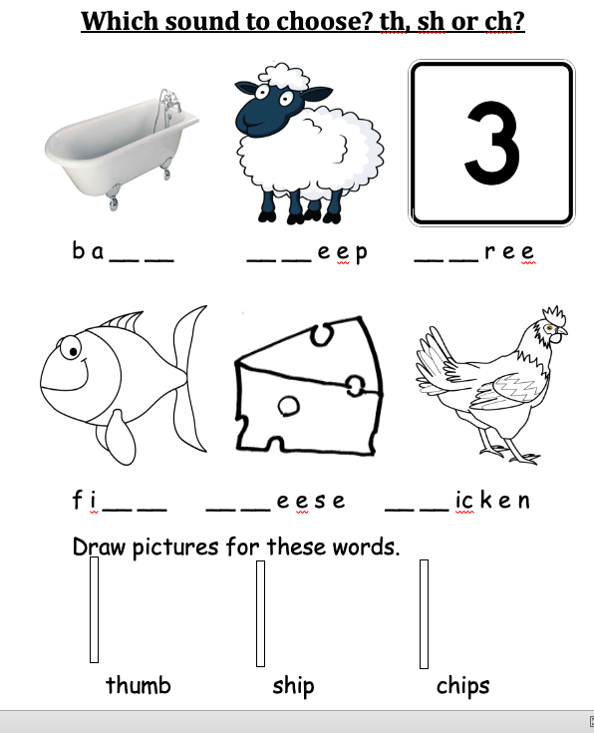

MONDAYS WORK

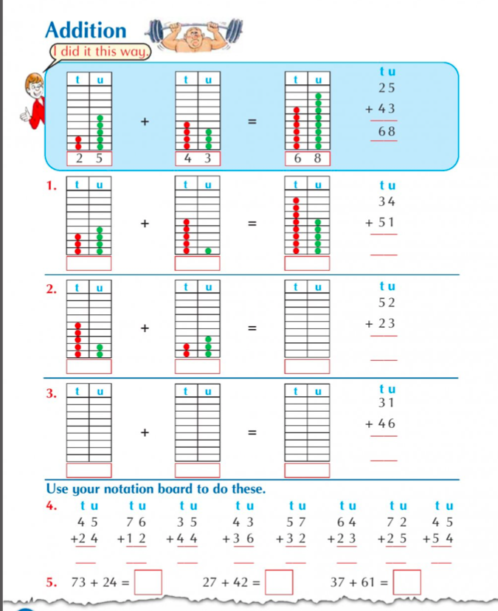
Ms. Gallagher’s Maths Group

Tables +5
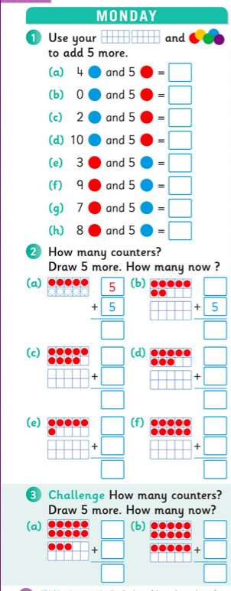
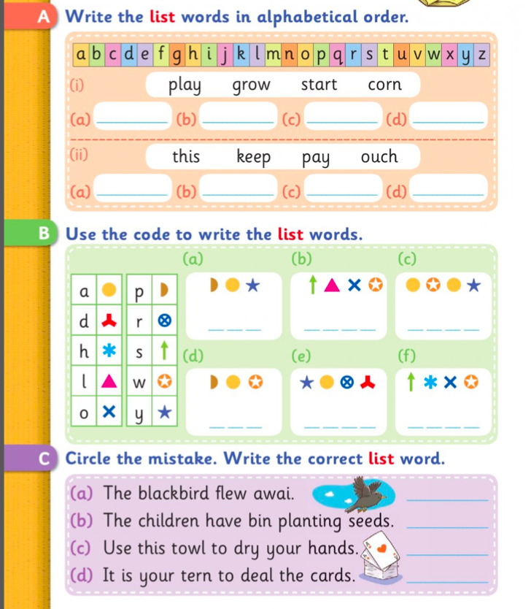
Spell Well (A+B)
Combined Skills Reader (Page 23 A for Monday)

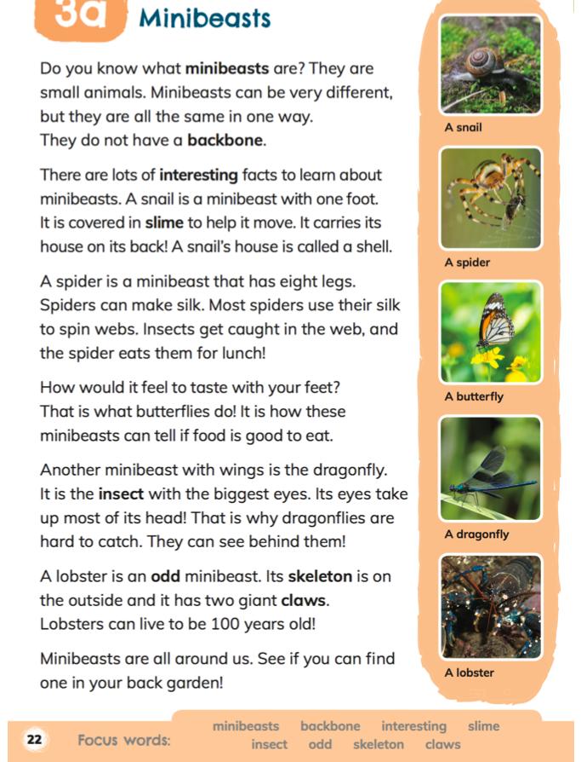

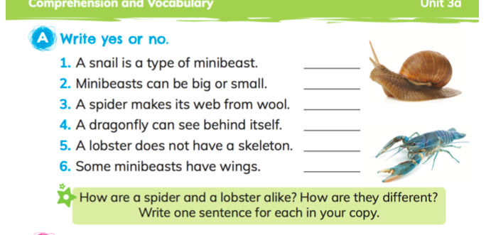

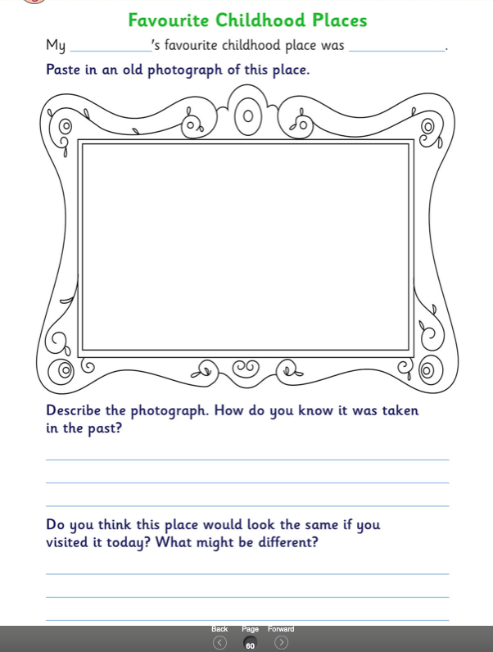
SESE- Favourite Childhood Places
TUESDAYS WORK
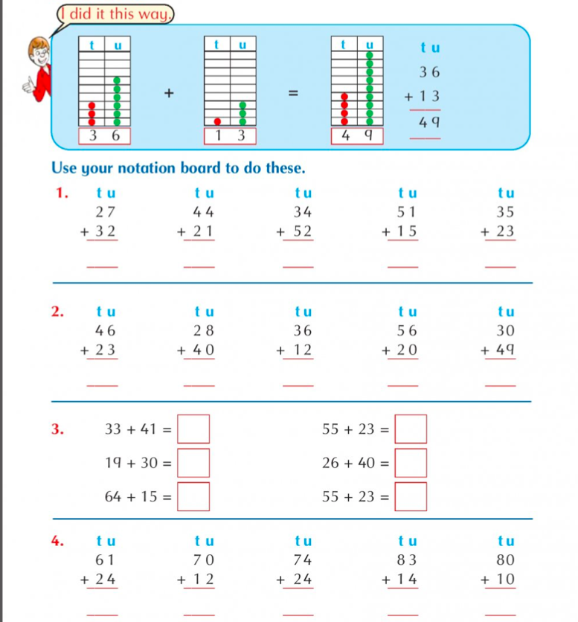
Ms. Gallagher’s Maths Group

Tables +5
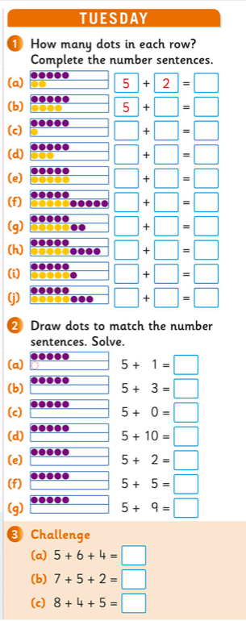
Spell Well- Page 52 C

Combined Skills Reader – Page 23 B & C

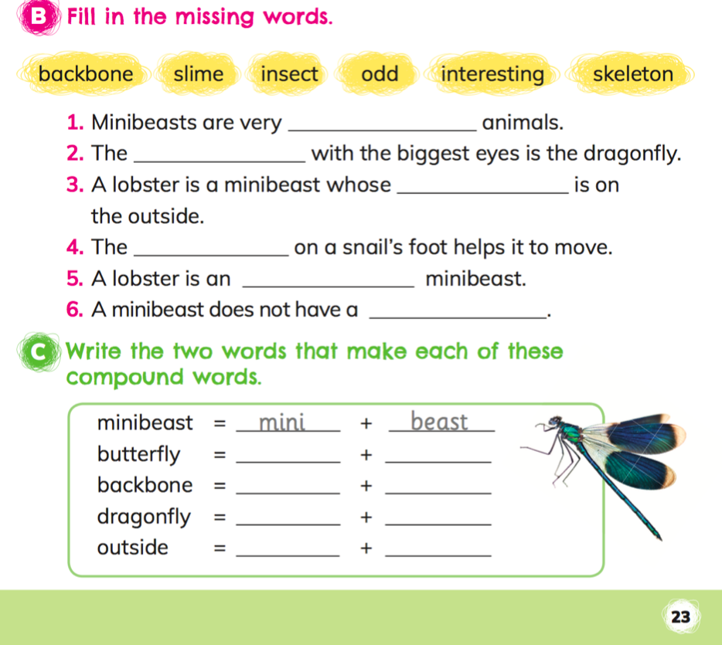
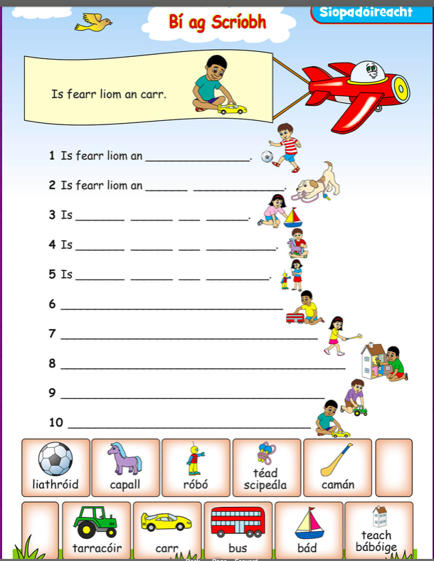

Gaeilge

WEDNESDAYS WORK
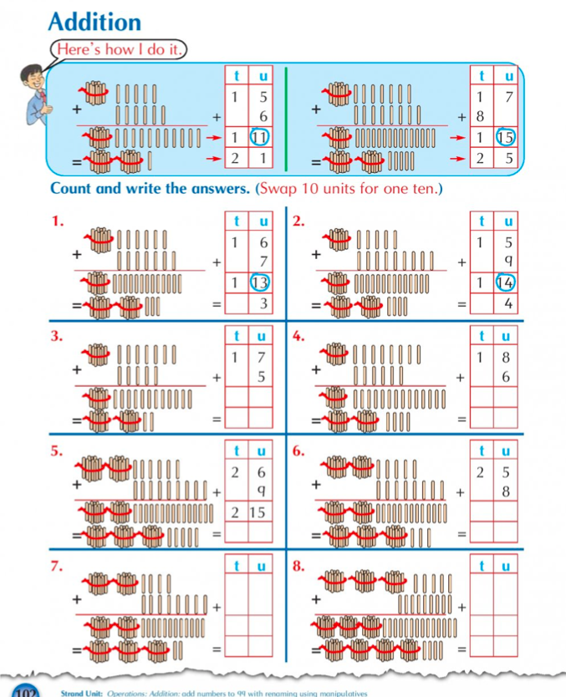
Ms. Gallagher’s Maths Group
Spell Well D & E
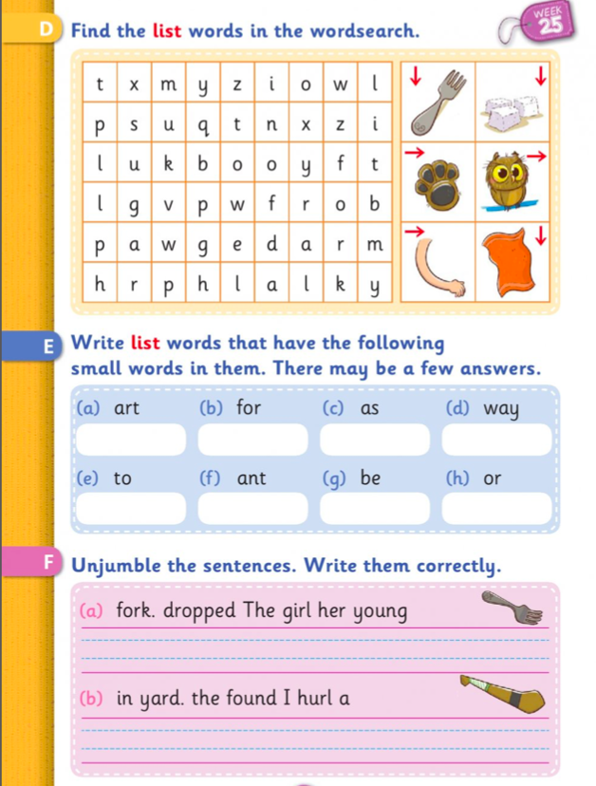

Combined Skills Book- Page 24 A
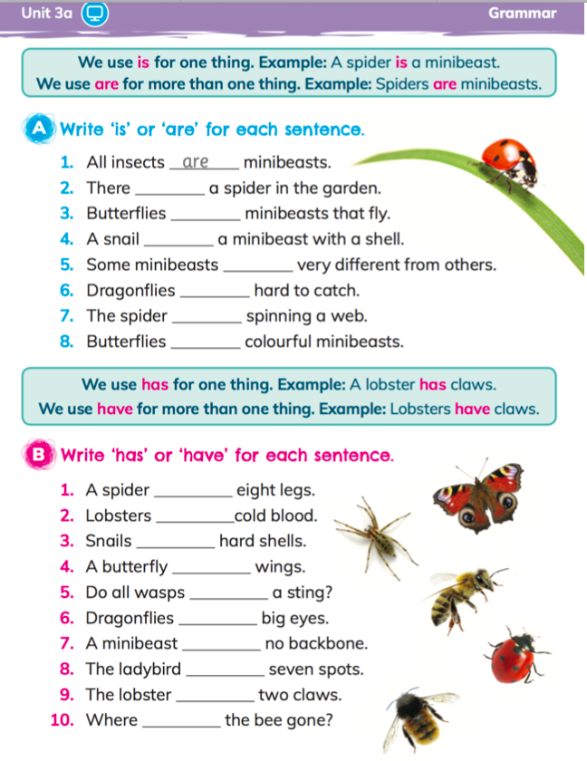

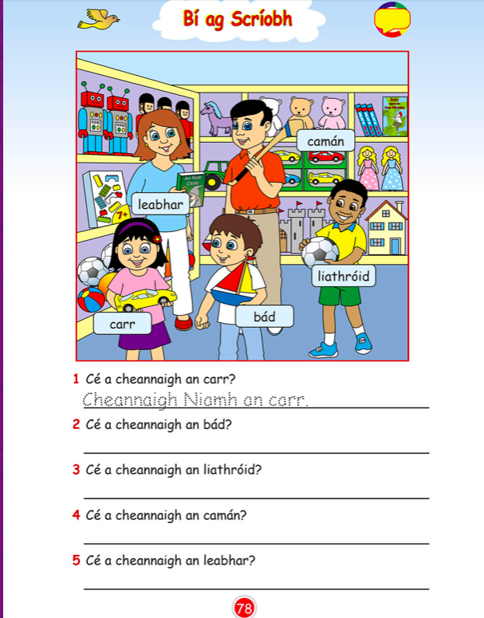
Gaeilge

THURSDAYS WORK
Ms. Gallagher’s Maths Group
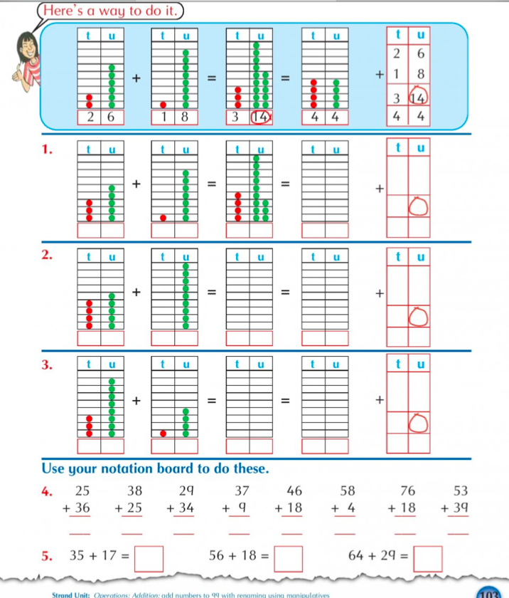

Tables +5 Thursday
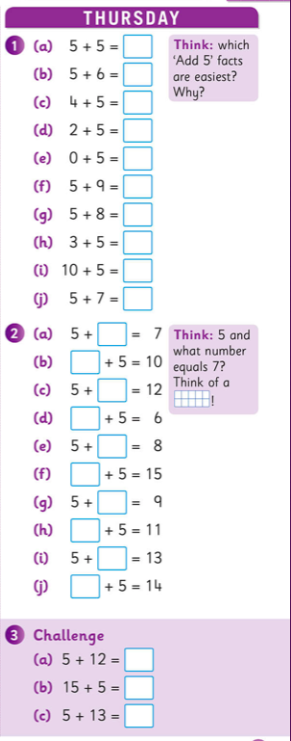

Spell Well- F

Combined Skills Reader- B

SESE- Thursday AND Friday

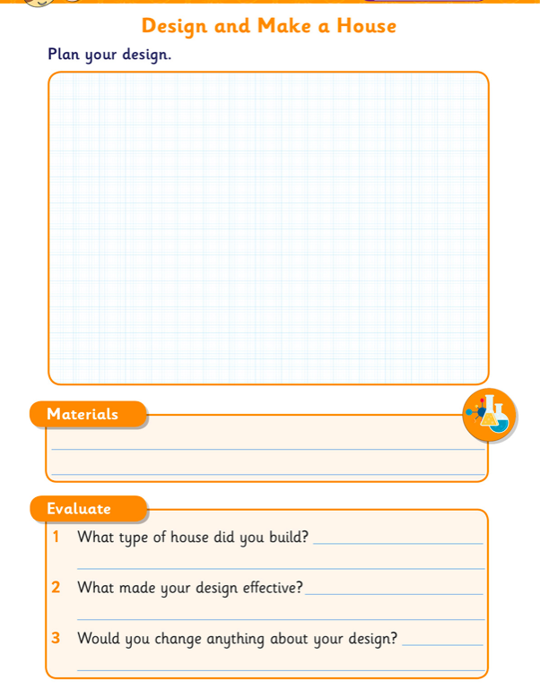

FRIDAYS WORK

Handwriting Page
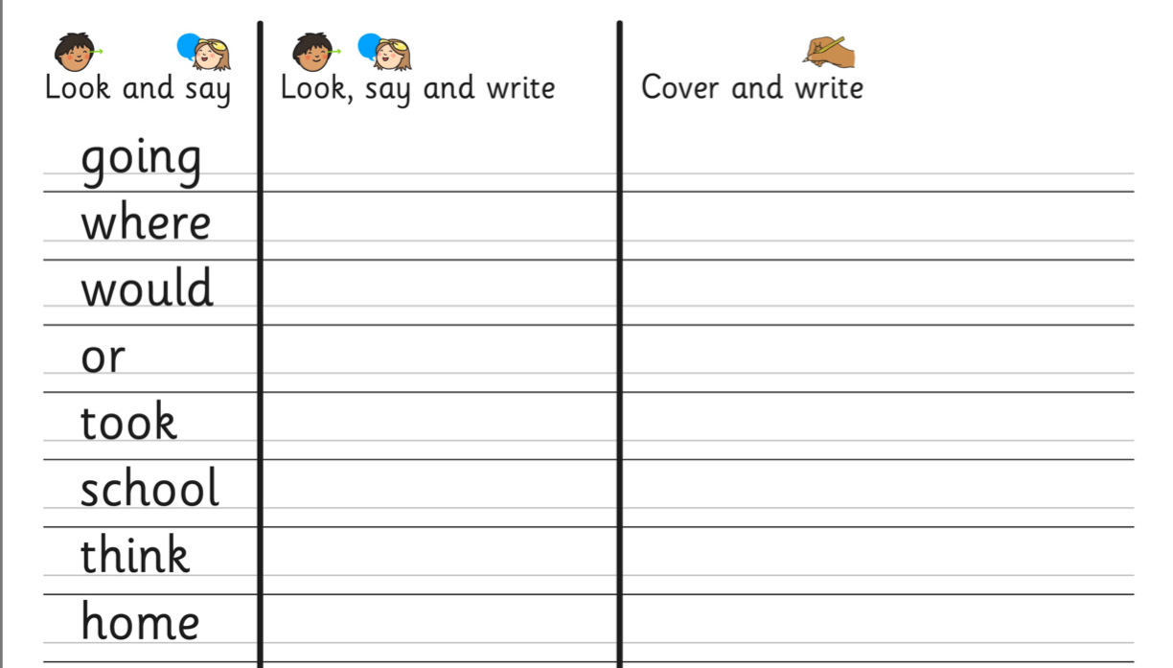

Spell Well- Pick 4 words from Page 52 and put them into sentences

