Monday

Maths
- Master Your Maths -Monday Column
- Ms. Gallagher’s Maths Group- Mathemagic Page 122 (Patterns) Q 1 and 2
- Tables- Add 6 worksheet- Monday

English
- Spell Well -Page 54 (A)
- Combined Reader and Skills Book – Story 3b- The Lifecycle of a Butterfly
Page 27 (A)
- Handwriting Page

SESE
Electricity at home

Work for Week 27th April- 1st May
First Class

Tuesday

Maths
- Master Your Maths -Tuesday Column
- Ms. Gallagher’s Maths Group- Mathemagic P.122 Q3 and 4
- Tables- Add 6 worksheet- Tuesday

English
- Spell Well -Page 55 B
- Combined Reader and Skills Book –
Story 3B – Read and do P.27 B & C.

Gaeilge
Practice counting in Gaeilge.
Write the numbers 1-10 on the worksheet below. (Page 79 in Bua na Cainte)

Wednesday

Maths
- Master Your Maths -Wednesday Column
- Ms. Gallagher’s Maths Group- Mathemagic P.123 Q1
- Tables- Add 6 worksheet- Wednesday

English
- Spell Well Page 55 C
- Combined Reader and Skills Book –
Story 3b- The Lifecycle of a Butterfly P.28 (A+B)

Gaeilge
Page 80 in Bua na Cainte.
The answers are:
- Tá rialóir uaim.
- Tá rón uaim.
- Tá rothar uaim.
- Tá ríomhaire uaim.
- Tá réalta uaim.
- Tá raidió uaim.

Thursday

Maths
- Master Your Maths -Thursday Column
- Ms. Gallagher’s Maths Group- Mathemagic P.123 Q2
- Tables- Add 6 worksheet- Thursday

English
- Spell Well – Page 55 D
- Combined Reader and Skills Book –
Story 3b- Page 29- Write a report on the honeybee.

SESE
Natural or Man Made?

Friday

Maths
- Master Your Maths -Friday Test

English
- Spell Well- Pick 4 words from Page 54 and put them into sentences.
- Handwriting Page
- Combined Skills Reader- Do the worksheet based on the lifecycle of a butterfly.

(Master your Maths: Link to answers https://my.cjfallon.ie/ebooks/23388.pdf )

***
This work below can be completed throughout the week on whatever day suits

- PE- IT IS ACTIVE SCHOOLS WEEK!

Active Schools Week is a very exciting week for our children. This year it is not possible so we are asking for your help with the Active HOME Week challenge, starting on the 27th of April.
The aim of this initiative is to motivate children to keep active at home by trying out NEW activities, taking on CHALLENGES and having FUN with family activities. To complete the challenge, children have to find four different ways of being active every day, making sure that this adds up to 60 minutes, or more, of physical activity. All members of the family are encouraged, #Together, to take on the challenge.
I have included attachment in the email of activities and ideas for Active Home Week. There is a Parent Information Document and a Challenge Chart to fill out!
- Art- Draw a colourful butterfly. Try use 6 different colours on its wings!

- Music- Tin Whistle – Revise the tin whistle scale and learn this song: Old Mc Donald Had a Farm (We will learn the next part of it next week )

**Ms. Mahoneys English Group- See separate document in email
Mondays Work

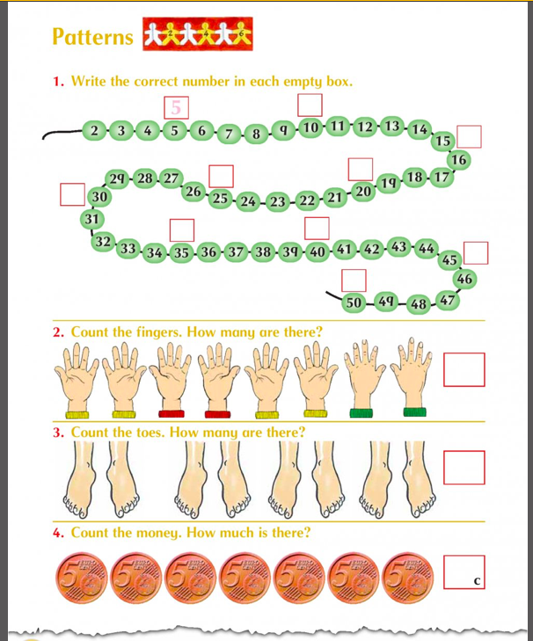
Mathemagic (Ms. Gallagher’s Maths Group) Q1 and 2

Tables- Mondays and Tuesday
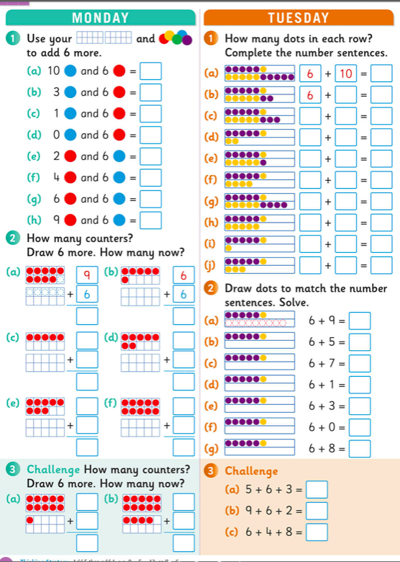

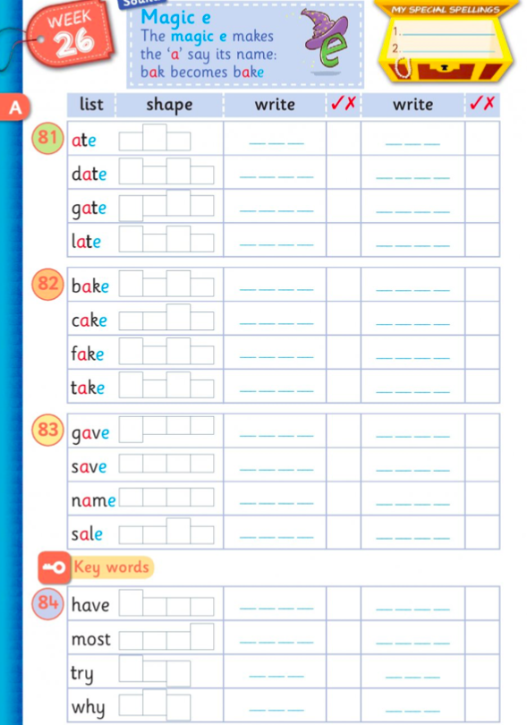
Spell Well Page 54 (A)

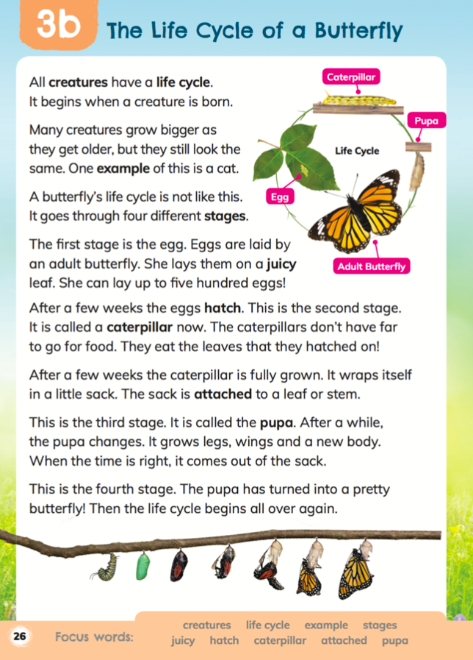
Combined Reader and Skills Book – Read

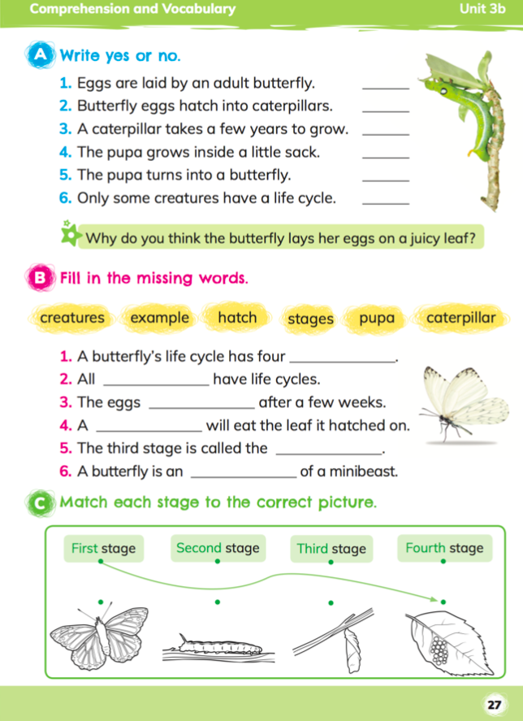
Combined Skills Reader Page 27 A

Handwriting Page
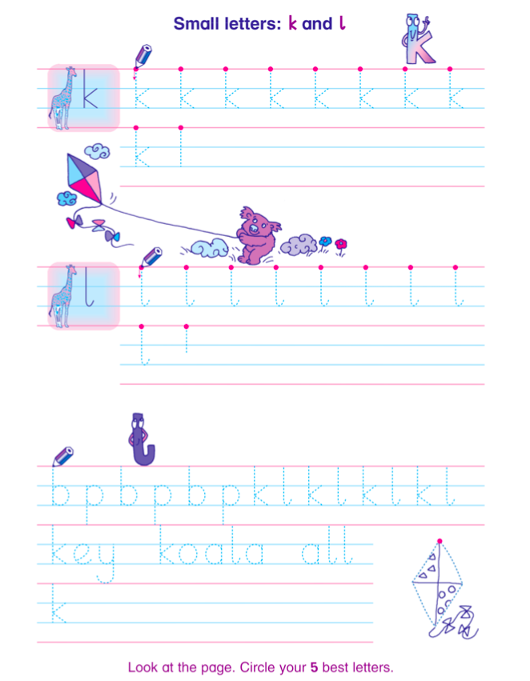

SESE- Electricity at Home
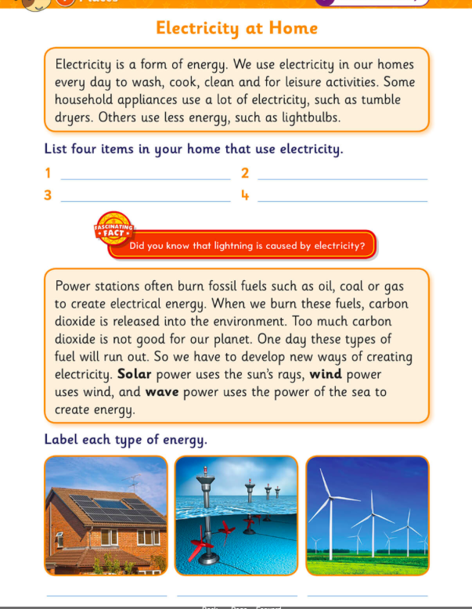

Tuesdays Work
Mathemagic (Ms. Gallagher’s Maths Group) Q3 and 4

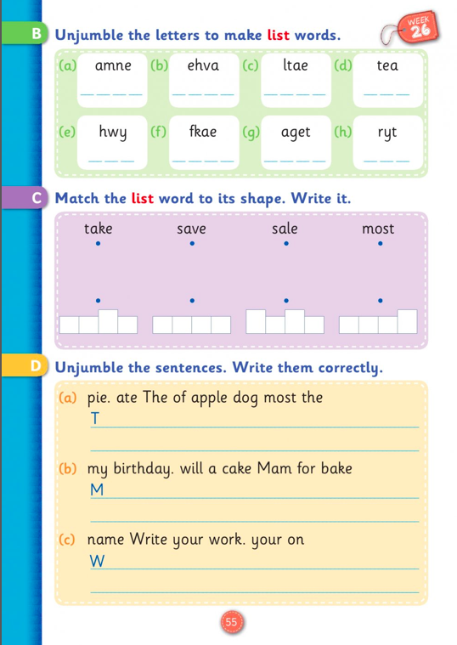
Spell Well- Page 55 B

Combined Skills Reader- Page 27 B and C

Gaeilge- Na hUimhreacha
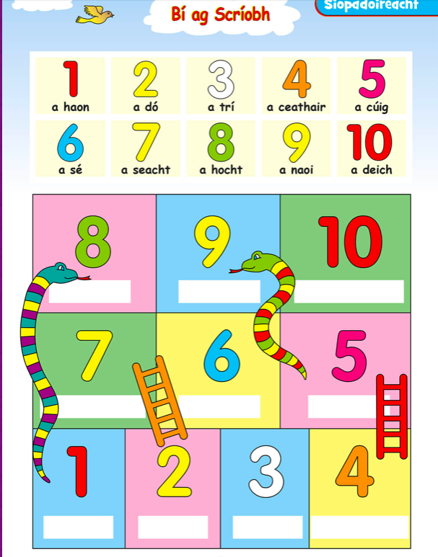

Wednesdays Work

Mathemagic (Ms. Gallagher’s Group)- P.123 Q1
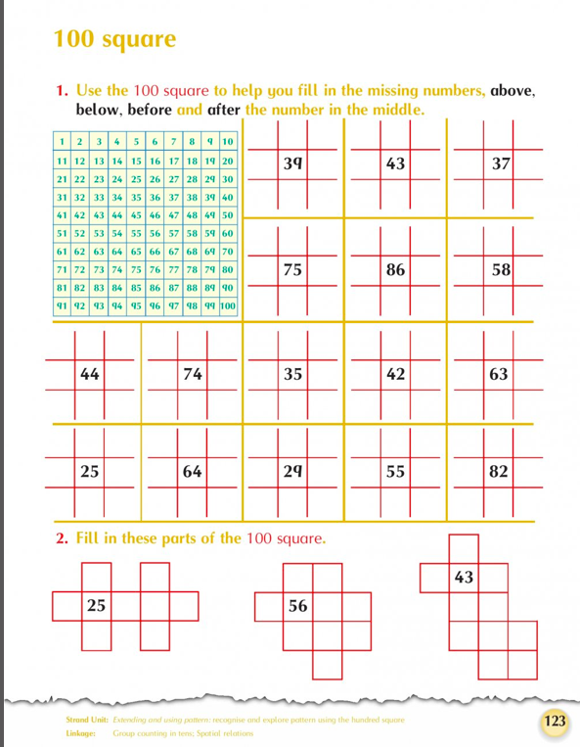

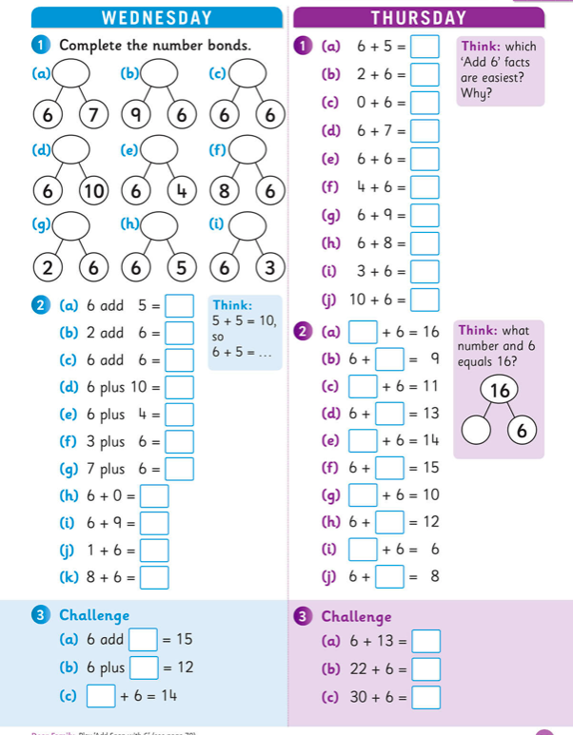
Tables – Wednesday and Thursday

Spell Well P. 55 C

Combined Skills Read P.28 A and B
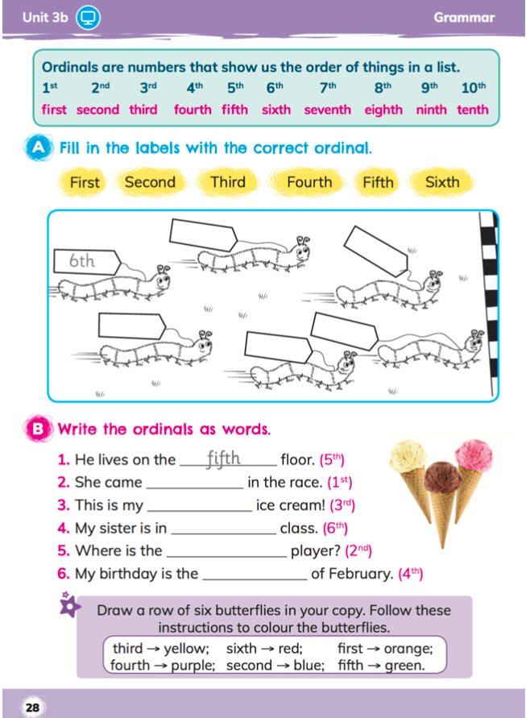

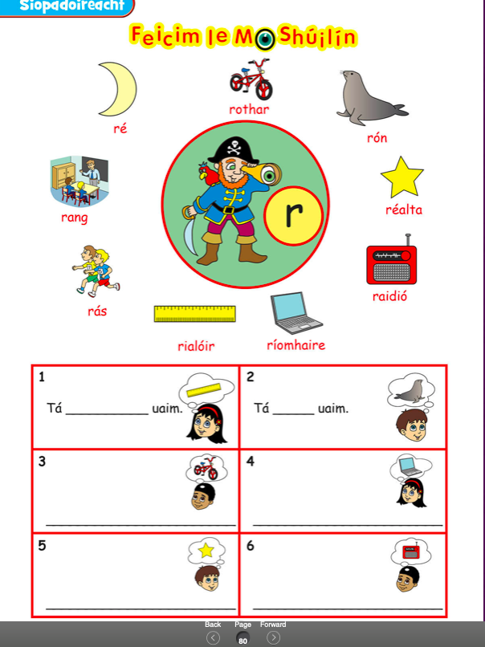
Gaeilge- Page 80- Ag Siopadóireacht

Thursdays Work
Mathemagic (Ms. Gallagher’s Group)- P.123 Q2
Spell Well- Page 55 D

Combined Skills Reader- Report on the honeybee
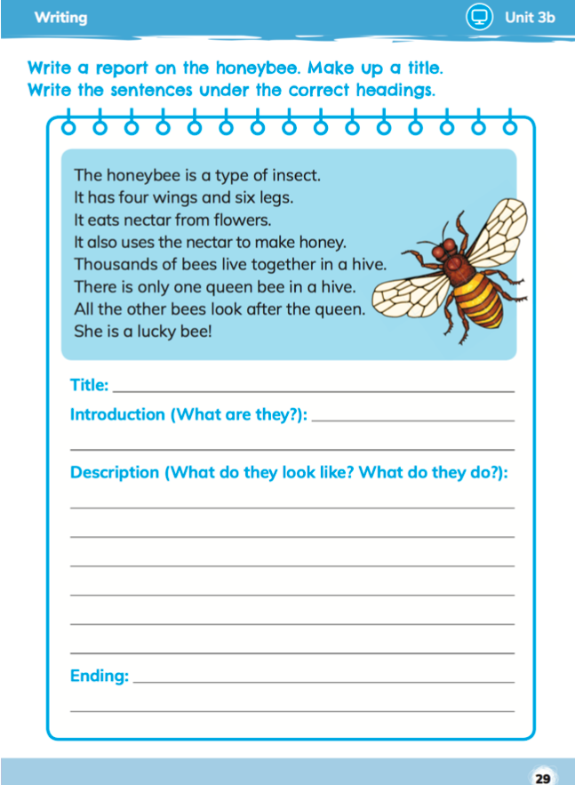

SESE- Natural or Man Made?
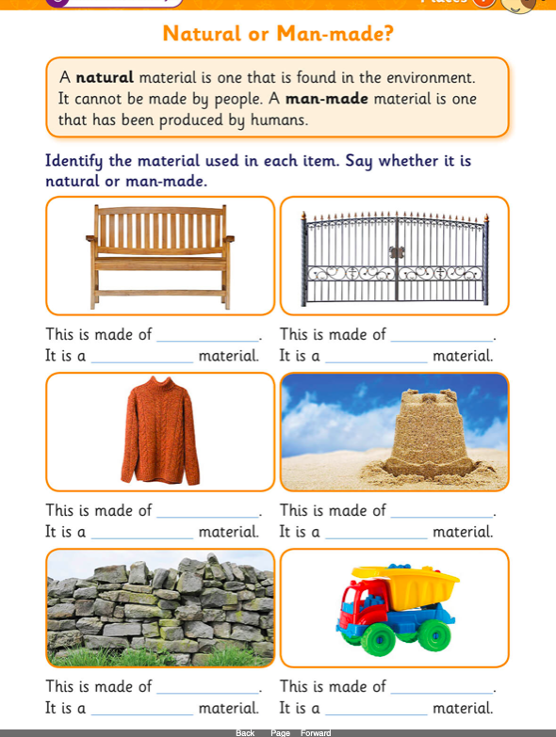

Pick 4 words from this page and put them into sentences

Handwriting Page
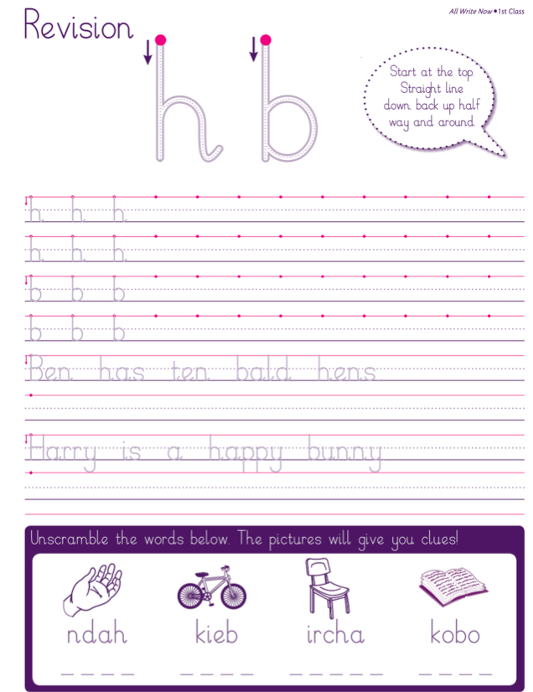

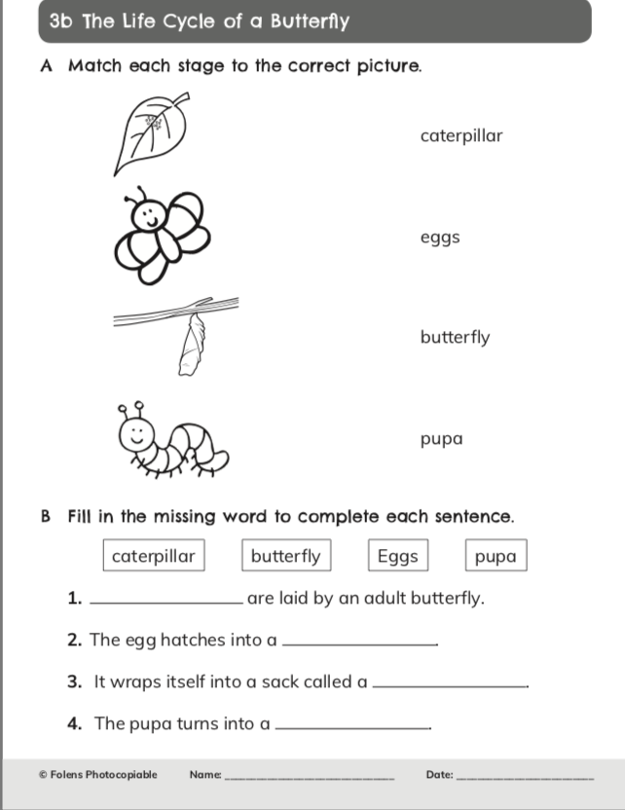
Literacy Worksheet

