

Hello boys,

I hope you are all well**. Monday is a bank holiday so you can take a break from school work that day!** You will be getting your written work in the post so it will be easier for you to do your work. I am still giving you your reading and games you could play here. I am emailing your work to your parents as well as uploading it to the website so it is easy to find. I would love if you could email me pictures of your work or videos of you reading during the week to my email address: [aisling.regan@stbrendansbns.com](mailto:aisling.regan@stbrendansbns.com)

Have a lovely week ☺

Miss Regan

This week you will get **two worksheets**

1. On the first page you will need to read the three words and choose the correct one. Don’t forget to colour the picture afterwards!
2. The second page is practising the two sight words ‘why’ and ‘which’. Do a word hunt around your house – Can you find either of these words hiding anywhere?

**Reading**

For your reading I am going to give you two books from the oxfordowls.co.uk website again.

To remind you, this is the website. You click my **class login** and the username is **missregan** and the password is **reading**

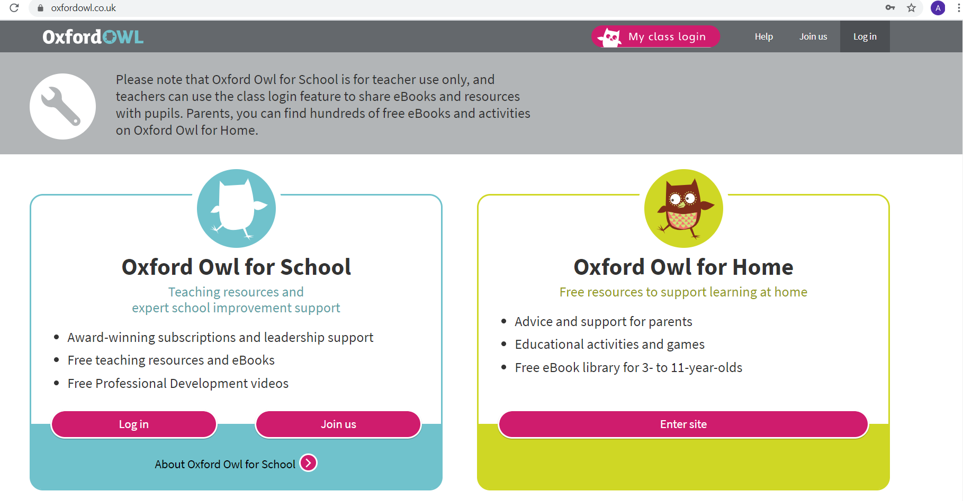

When you get logged in, I would like you to read these two books over the week. Read a few pages per day. You can search for them using the search tab. Happy reading!

