Mr Blake’s class work: week 3- May 4th to May 8th.

Hi all,
I hope ye are keeping well during these trying times.

Please remind the boys to do their homework in their Spellbound and Ceartlitriú books. There is a hint box beside part c+d for p65 Ceartlitriú (click enable editing to read).

Please keep writing your diary entries daily in a copy.

As we are finished Master Your Maths we will be giving worksheets to complete in their copies. This week’s topic is area + symmetry (pages 86-88 attached). There is a sums page also to keep the brains working; page 24 (attached).
Remind the boys to rule their maths copy and write the page and number+letter of each sum. Remind them to practice neat handwriting at all times.

Try to stick to the timetable if possible for the benefit of a routine for the boys. If there is other work assigned this can be completed in their vocabulary copy or if you have a printer you can print the worksheets and fill them in. Ms. Walsh and Ms. Callaghan’s boys have separate documents to help them with this class work.

For PE there is an activity sheet which the boys can fill in as they do their exercises. If you can’t print this you can get the boys to fill in their activity booklet which should be in their schoolbags.

SPHE: I would like the boys to reflect on how they are feeling by completing the mindfulness worksheet which has a guide on what to write about and a lovely colouring sheet for afterwards.

Encourage the boys to keep washing their hands, keep social distancing and cough etiquette, and most importantly stay positive and keep smiling. Keep helping your parents with housework!
School Hub is on RTE at 11am and Cúla is on TG4 at 3pm.

Mr. Blake

 | Monday | Tuesday | Wednesday | Thursday | Friday
Maths | Tables : Revise x7  Use Topmarks Website for fun practice games  Worksheet: p24 Q1-6  P86 q1-5 | Tables: Revise x7  Use Topmarks Website for fun practice games  Worksheet: p 24 Q7-12  P86+87 q6-10 | Tables: Revise ÷7  Use Topmarks Website for fun practice games  Worksheet: p 24  Q13-18  P87+88 B q 1-6 | Tables: Revise ÷7  Use Topmarks Website for fun practice games  Worksheet p 24 q19-24  P88 B q7-12 | Tables Test : x7  ÷7  Worksheet p24 q25-30
English | S Bound: U31 Box 1 Part A/B  Reading: Cool Clive Ch1.  Oxfordowl.co.uk see below for link  Writing:  Diary. Adjectives worksheet A 1-6 | S Bound: U31 Box 2 Part C/D  Reading: Cool Clive Ch2.  Oxfordowl.co.uk see below for link  Writing:  Diary.  Adjectives worksheet A 7-12 | S Bound: U31 Box 3 part E/F  Reading: Cool Clive Ch3.  Oxfordowl.co.uk see below for link  Writing:  Diary  Adjectives worksheet  B 1-6 | S Bound: U31 Box 4 part G/H.  Reading: Cool Clive Ch4.  Oxfordowl.co.uk see below for link  Writing:  Diary  Adjectives worksheet  B 7-12 | Spelling Test:  Unit 31  Writing:  Diary
Irish | Ceartlitriu: A20 p66 first3 spellings.  P67 A | Ceartlitriu: A20 p66 next 3 spellings. P67 B | Ceartlitriu: A20 p66 next 3 spellings.  P67 C unscramble spellings. | Ceartlitriu: A20 p66 last 3 spellings.  P67 D pick the odd one out. | Spelling test: pick any 10 spellings from this week.
SPHE | Mindfulness worksheet. This will help the boys to reflect on their feelings during Covid 19 restrictions.
PE | Each day, do exercises in 7s like our Maths! You could do 7 squats and 7 star jumps, followed by 7 push ups.  Try to figure out how many times you will do the 7 squats to reach 28 squats!  Set yourself a target each day and try to beat it every day! For Example. Monday, I will do 7 squats a total of 8 times = 56 squats (7x8=56).  On Tuesday, try to do 63 (63 ÷ 7= 9 times) etc. Record them on your activity sheet attached.  We will also practice our running technique this week. Find a space outdoors where you can sprint for either 30 or 15 metres. When running keep your head up, looking straight ahead, swing your arms while running and lift your knees up as you sprint. If you have only the small space (15m) double the runs. Run at full speed for 30 m using the correct technique 4 times with a 15 second break between each run. Take a 1 minute break, then do the 30m run 7 times with a 15 second break between each run. Then walk the 30 m twice as a warm down.
Oxfordowl.co.uk: ‘Ebooks’ My Class Login: Third class! Nb: Don’t forget the exclamation mark (!) Password: Ilovereading Age groups 7-9 ‘Cool Clive’

Careful with your writing! Don’t forget the capitals at the beginning of a sentence and for people/places/titles etc!

Keep washing your hands and stay safe! Help at home and enjoy the time together!
Mr. Blake, Mrs. Callaghan, Ms. Walsh.
Religion | Hail Mary | Hail Mary | Hail Mary | Hail Mary | Hail Mary

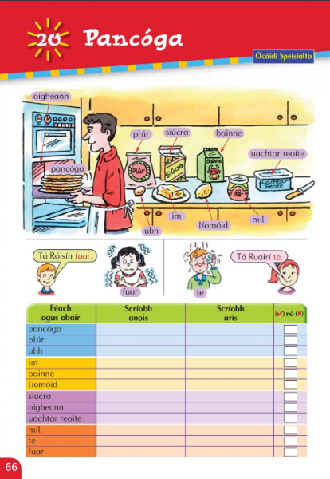

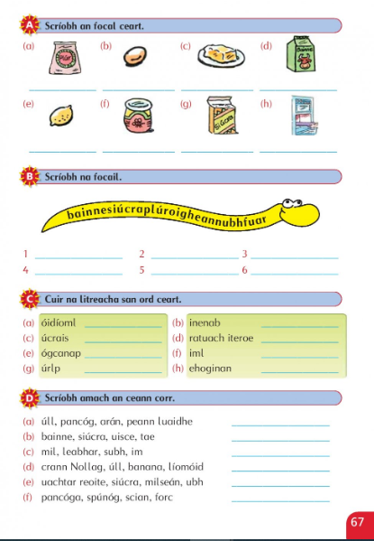
Unscramble spellings
Pick the odd one out

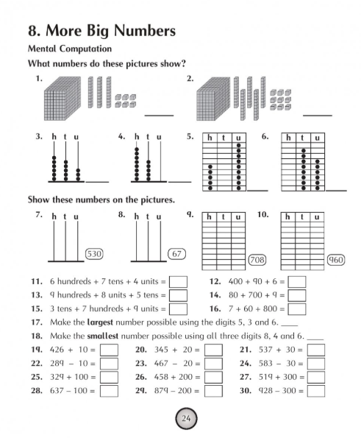

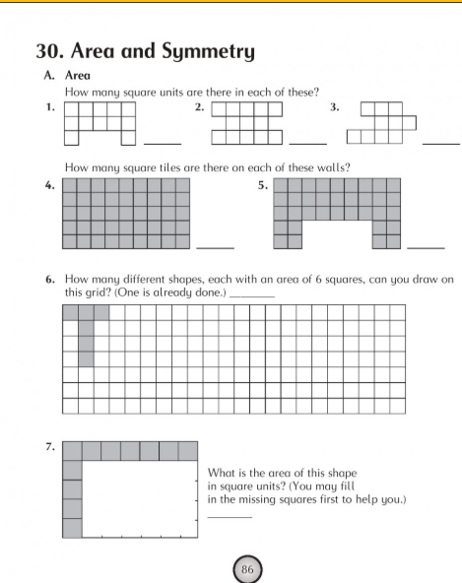

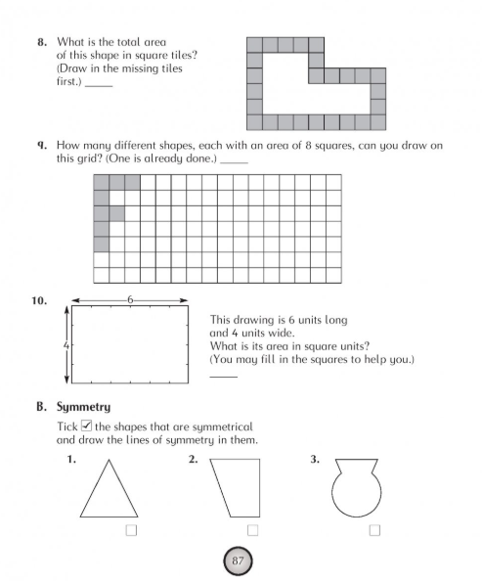

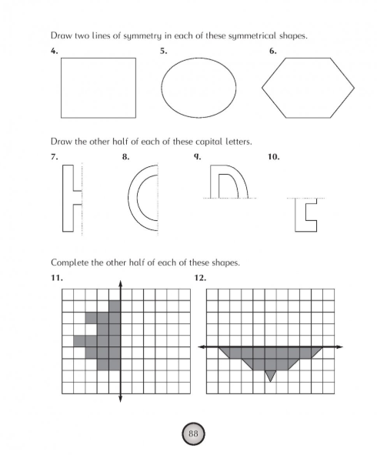

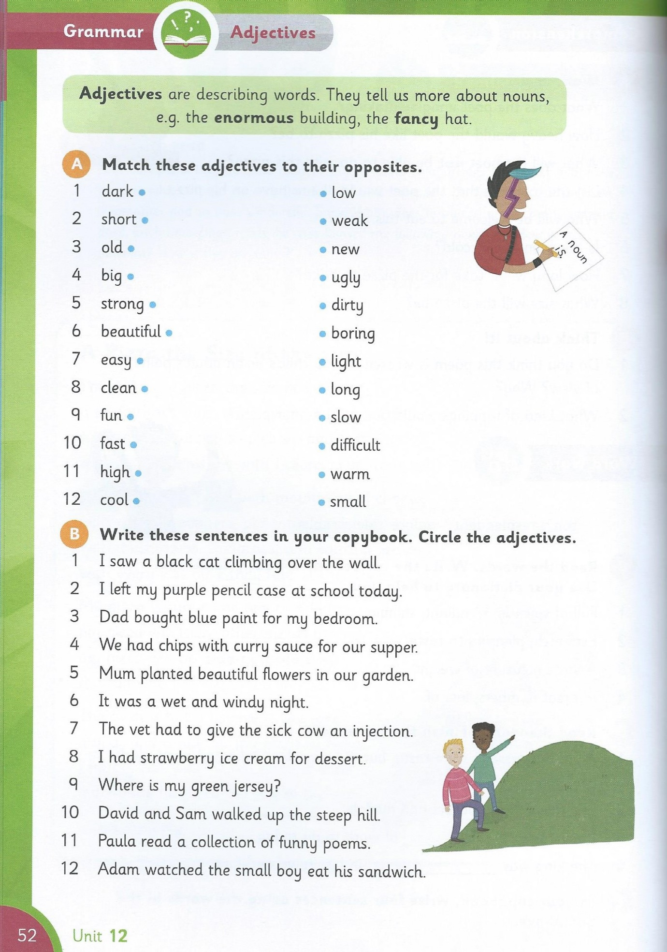

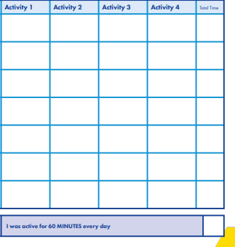
M

T

W

T

F

S

S
