Week Beginning: Mon 4th May
Dear Students
Hope you are all keeping well!
We are delighted to hear from you each week and look forward to looking at some of your work, when possible!
This week Mr Blake has chosen a lovely book called ‘Cool Clive’ for your reading! It will make you laugh! We are looking at Ch 1,2,3 this week but if you feel like reading on, that’s great too!
Oxfordowl.co.uk: ‘Ebooks’ My Class Login: Third class! Nb: Don’t forget the exclamation mark (!) Password: Ilovereading Age groups 7-9 ‘Cool Clive’
You could read it aloud with one of your family and show them your good reading!
‘Cool Clive’
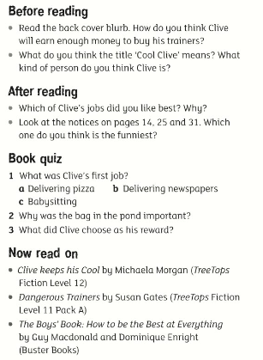

Adjectives are great ! They help us get a better picture of what we see….
We would like you to use more adjectives in your story writing because it gives a better picture to your reader…..
A black cat A purple pencil blue paint curry sauce beautiful flowers
Match the Opposites: ( We have matched the first few, so it should make it easier with the last 6….make sure to cross them out as you go, to make it easier to see what is left!)
- Dark – light short- long old – young
- big-small strong- weak beautiful-ugly

