Language/EAL Tips
Week Beg – 4th May
Talk about the picture with your family.
We have written some answers to the questions to help you practise saying a full sentence.

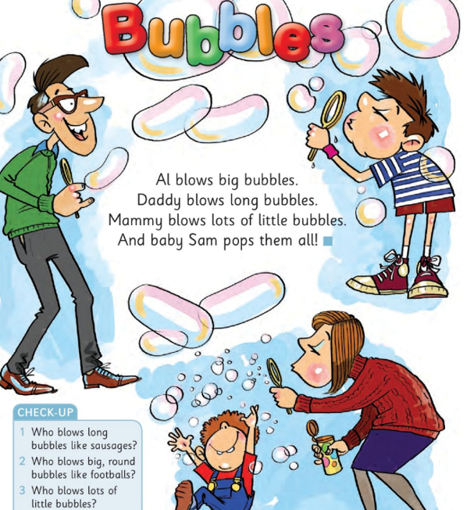
Bubbles
- Who blows long bubbles like sausages?
Daddy blows long bubbles like sausages.

- Who blows big round bubbles like footballs?
Al blows big round bubbles like footballs.

- Who blows lots of little bubbles?
Mammy blows lots of bubbles.
- Who pops them all?
Baby Sam pops them all.

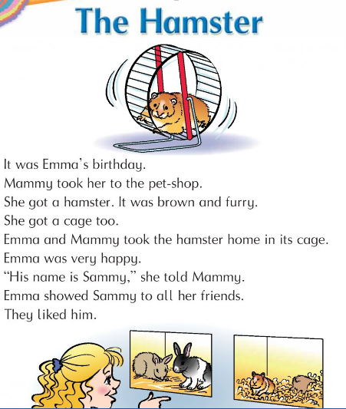

- Where did Mammy take Emma for her birthday?
Mammy took Emma to the pet shop.

- What pet did she buy?
She bought a hamster.

- What colour was the hamster?
The hamster was brown and furry.

- What is the hamsters name?
The hamsters name was Sammy.

Friends hamster cage pet-shop

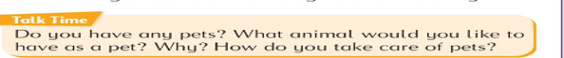
I have a pet. I do not have a pet.
I would like a cat / dog/ hamster/
I would feed my pet every day. I would give it fresh water to drink.
I would clean out the cage every week.
I would walk my dog.
I would play with my cat.
I would play with my hamster.

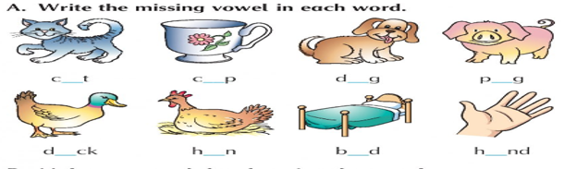
Cat cup dog pig
Duck hen bed hand

