P 1 of 2 Week beginning Monday 11th May 2020
Hi boys,
Here are some language/EAL tips based on ‘Doing Words’ and last week’s work.
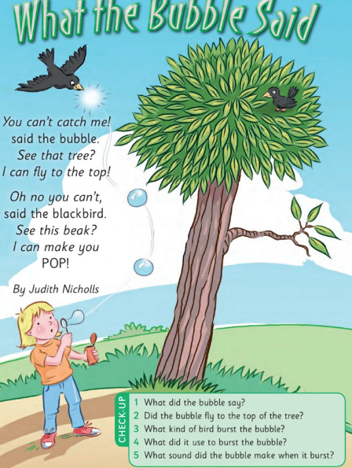

Let’s make some sentences with ‘doing word’. Doing words are also called verbs.
Read the sentence and point to what is happening.
- The boy is standing on the path.
- The boy is blowing bubbles
- The bird is flying in the sky.
- The other bird is sitting in the tree.
- The bubbles are floating in the air.
- The bird is popping the bubbles.
See can you make your own sentence with each verb. How many could you make?
P 2 of 2 Fill in the blanks using the words from the box.
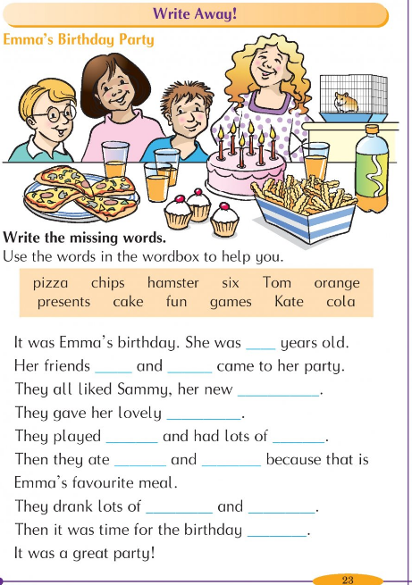

Chat about the story
- Who’s birthday was it? It was………………
- What age was she? She was ……………. years old.
- When is your birthday? My birthday is in ………….
- What age will you be? I will ……….. years old on my birthday.

Watch School hub on TV every day at 11:00.
Stay safe and keep washing your hands.
Slán, Mrs Callaghan & Mrs Walsh

