Mrs Mahoneys Maths (Ms McCarthy's Second Class) May 5th -8th

Continue doing Master Your Maths every day.

Click here to watch a video reminding you how to do renaming - renaming

Click here -subtraction with renaming to watch a video showing you how to do subtraction with renaming.
Use this poem to help you
More on the top, no need to stop. ( You have enough units to take away)
More on the floor, go next door, get ten more. (You don’t have enough units to take away. So you rename)

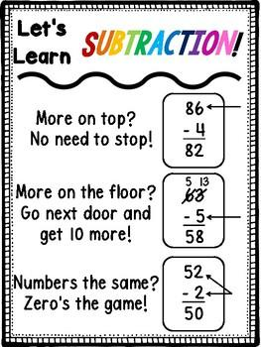

Tuesday Mathemagic page 87 1-9
Wednesday Mathemagic page 88 Q1
Thursday Mathemagic page 88 Q2
Friday Mathemagic page 88 Q3
