Mrs Mahoneys Maths (Ms McCarthy's Second Class) May 11th - 15th

Continue doing Master Your Maths every day (you may be finished the book now)

Click here to watch a video reminding you how to do renaming - renaming

Click here -subtraction with renaming to watch a video showing you how to do subtraction with renaming.
Here is another video to help you. https://www.youtube.com/watch?v=Buyaqe_L5-Y
Use this poem to help you
More on the top, no need to stop. ( You have enough units to take away)
More on the floor, go next door, get ten more. (You don’t have enough units to take away. So you rename)

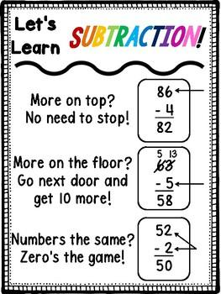
Monday - Mathemagic Pg 89 Q1-8
Tuesday - Mathemagic Pg 90 Q 1-9
Wednesday - Mathemagic Pg 91 Q1
Thursday - Mathemagic Pg 91 Q2
Friday - Mathemagic Pg 91 Q3
