Work for pupils attending Mrs. Broderick and Mrs. Lawless
April 5th May – May 8th 2020
- 6th Class Maths Group
Master Your Maths 4 Week 27
Revision of multiplication tables 4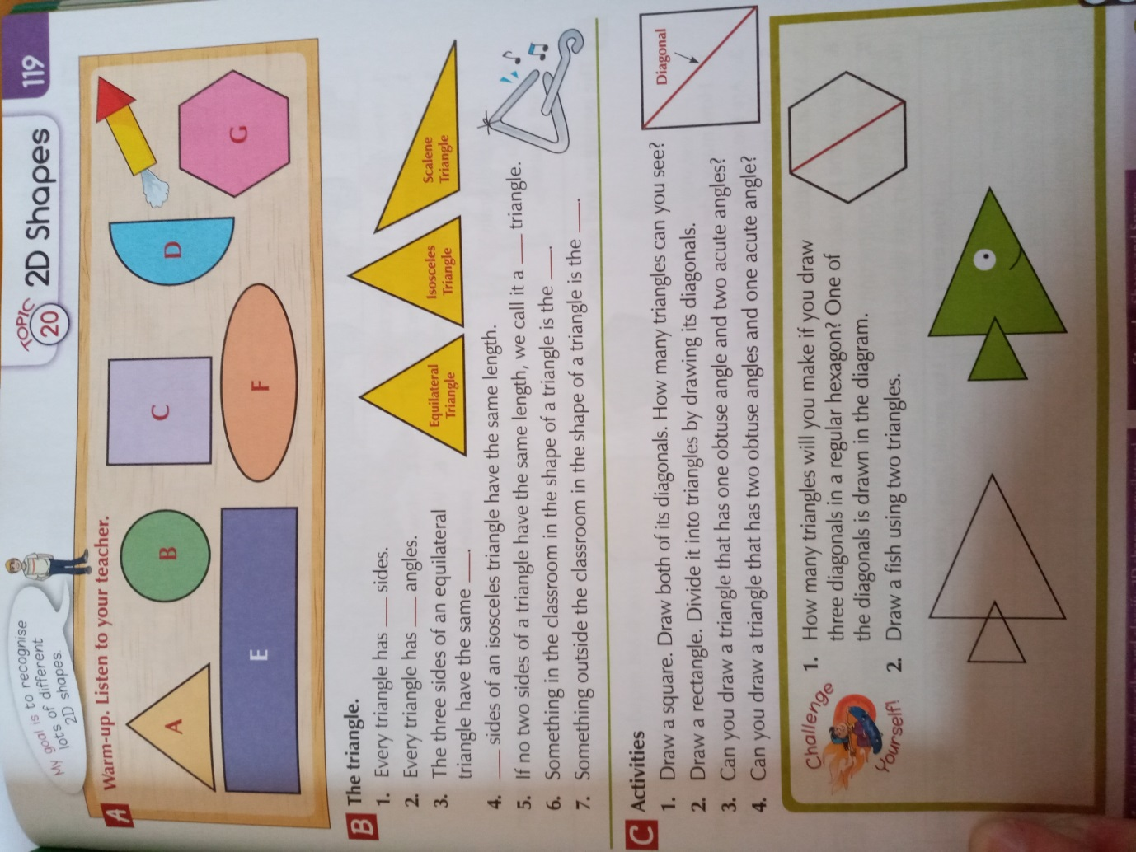

- 5th Class Maths Group
Master Your Maths 4 Week 27

Revision of multiplication tables x4
- 6th Class English Group
Spellbound D Unit 27 A-H
Learn spellings (Boxes 1-4) and put spellings into sentences
Read library books sent home or any other books of your choice
Write a diary entry of 8 sentences at the end of the week.
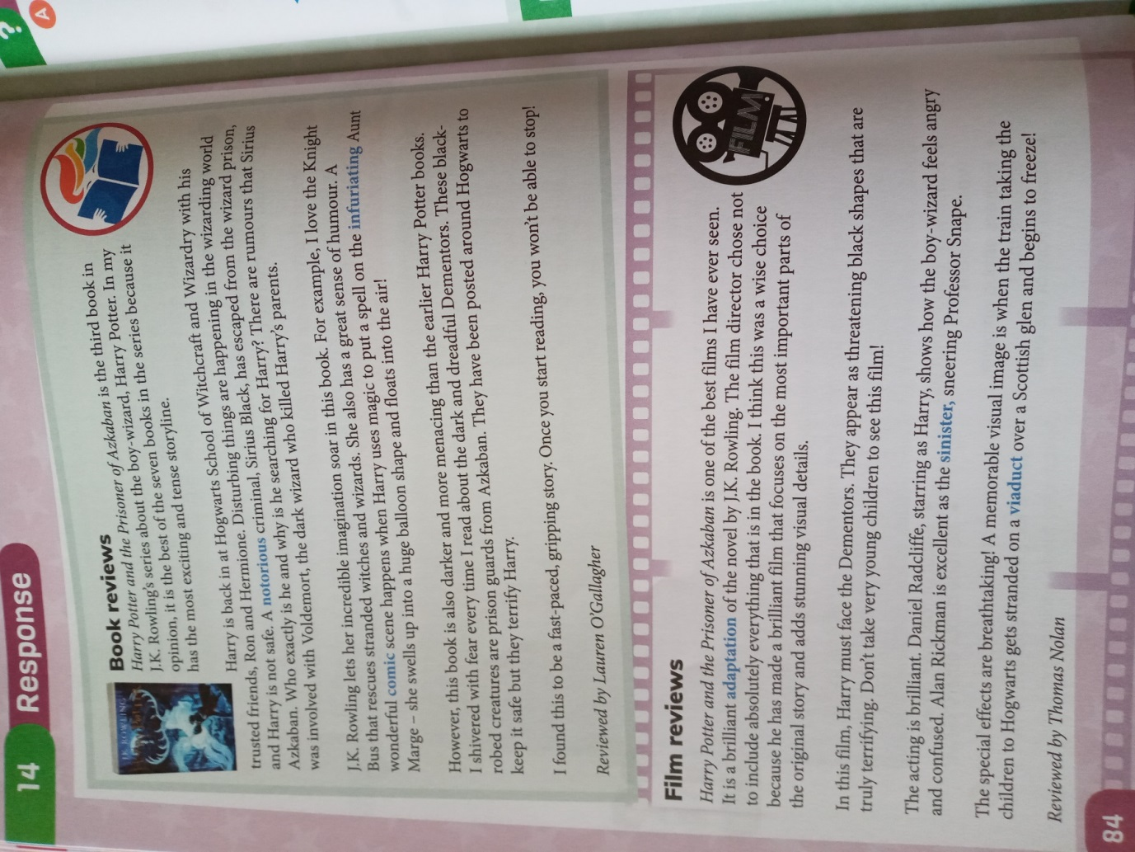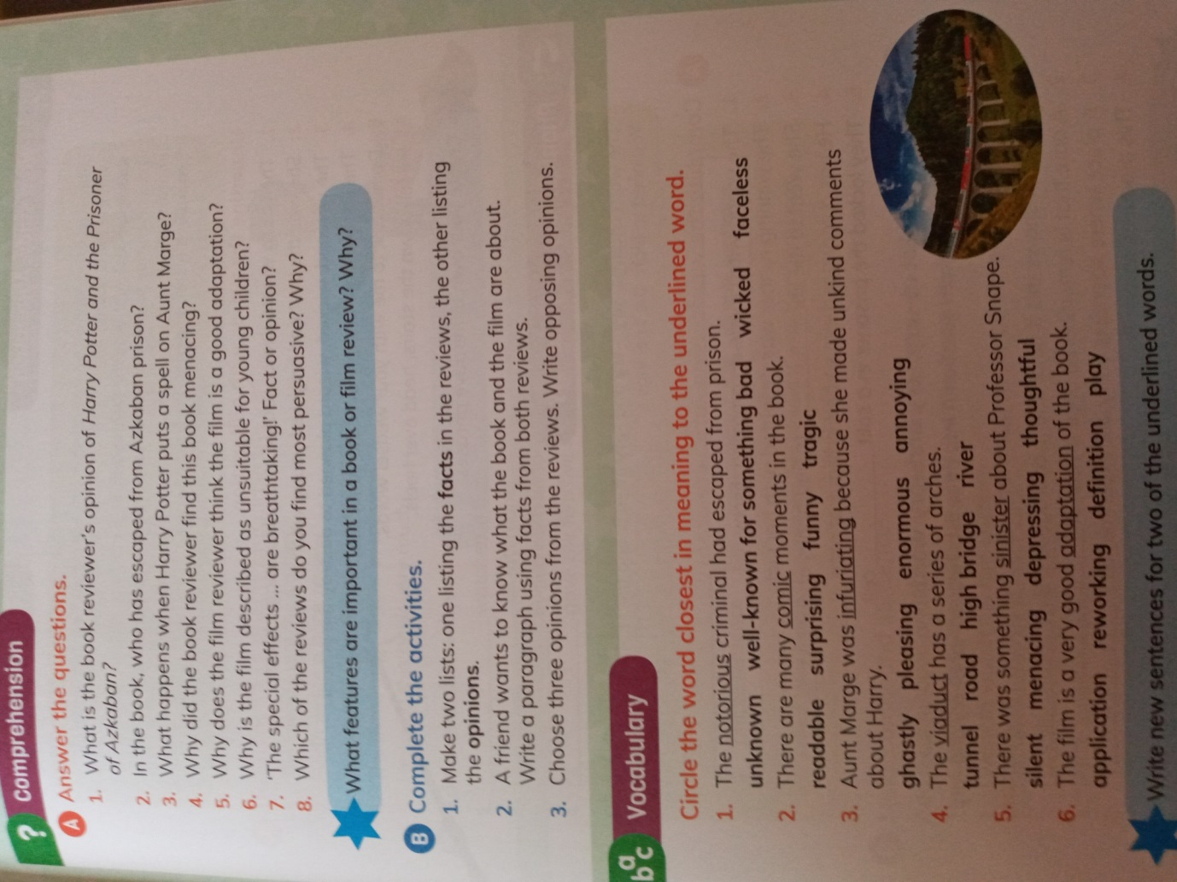

- 5th Class English Group
Spellbound C- Unit 27 A-H( Mrs Broderick)
Learn spellings (Boxes 1-4) and put spellings into sentences(Mrs. Broderick)
Read library books sent home or any other books of your choice
Write a diary entry of 4 sentences at the end of the week.
Write about a Sunny Day.

