Hi guys.

It’s hard to believe we are into week seven of work. Time is flying!

Well done on your English, Irish and Maths work. I understand that it can be difficult to stay motivated but it is important to realise that all the work you are doing now will make things easier for next year.

The process, presentation and assessment of projects are of a secondary school standard. It is wonderful to see how much initiative you are using and witness the self-directed learning that is taking place. It is a real sign of maturity and is a fantastic skill to be developing. Well done! I especially want to mention Conor Dillions World War 2 project completed to a very high standard.

This week I have been very impressed with your land yachts, May altar and art work. Cathal Howard’s ‘Croc in the beach’, Conor Lyons’ comic strip, Sean Mcloughlin’s May altar and Ben Pollock’s, Daryl Howard’s, Sean McLoughlin’s and Daniel O’ Flaherty’s land yachts were very noteworthy. Keep an eye on the school website / twitter account in the coming weeks to get a peek.

The pupils who signed and returned their Seesaw consent forms will be getting an email soon with your personal code to access your journal. If you do not receive a password in the coming days, please let me know. For those who have not returned your consent forms, please do so as soon as possible.

Please find attached work for this week. If you have any questions send me an email and I will try my best to help. If you go to Ms. Broderick / Ms. Lawless make sure to access their work on the link on the website.

Send on all completed assignment so I can assess how you are getting on.
Most importantly stay safe and look after your loved ones.

Regards,

S. Fox

Maths

1. Master your maths week 29 and test 29.

2. Matamagic - Please let me know how you found working from this book last week.

Matamagic answers For 5th class Time Based on Week 6

P93 Q 1 c 1hr 37min d 2hr 15min
Q 2 c 78min d 138min
Q3 c 8hrs 11min d 9 hrs 17min
Q4 c 3hrs 35min d 3hrs 38min
Q 5 c 27min d 3hrs 26min
Q6 c 17hrs 55min d 8hrs 30min
P 94 Q 1 g 12.30pm h1.55am i 9.45pm
Q2 12.00, 14.00, 15.00, 16.00, 17.00. 18.00, 19.00. 21.00, 22.00, 23.00
Q3 g 23.40 h18.17 i 20.34 j 22.10
P 95 Q1 e 11.05am f 6.24pm
Q2 e 5hrs 45min f 3hrs 43min
Q3 e 21.12 f 22.35
Q4 e 16.46 f 18.54
Q5 d 2hrs 15
Q6 d 2hrs 10
Q7 d 45min
Q8 d 2hrs 5min
P 96 Q1 14.33, 16.38. 18.53, 21.03, 23.18 Q2 22.53 Q3 1hr 55min
Q4 9hrs 35min Q5 15.33, 17.43, 19.58, 22.13 Q6 1hr 40min
Q7 13.52 Q8 4hrs 40min Q9 5hrs 40min Q10 4.33pm
Q11 8.02pm Q12 8.40 Q13 5hrs 51min

We will focus on data this week

This book can be accessed on CJ Fallon website online. Log in as a student (you may need an email address that you can use). Select level, class, subject, series, title and online book. The name of the book should appear and click on it. It should then download. Will be eager to see you bar chart and multiple bar chart.

Monday | The following table shows the number of visitors to a park for the months January to March.  Month January February March  Number of visitors 150 300 250  a) Construct a vertical and a horizontal bar chart for the table.  b) Write four questions based on the bar chart
Tuesday | 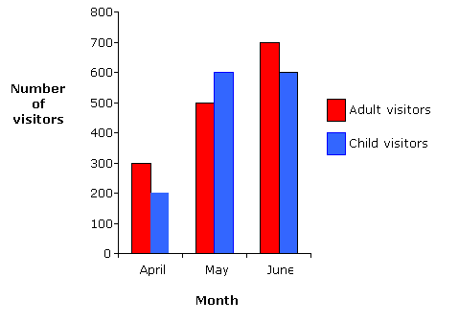  This is a multiple bar chart based on the number of visitors, adult and children, to a park in April, May and June.  I would like you to make up your own data and draw a multiple bar chart to show how many of 3 different chocolate bars were sold in week one v’s how many were sold in week 2.  Make up five questions to go with your multiple bar chart.
Wednesday | P 157 Q 3  P 158 Q 3
Thursday | P 158 Q 4  P 159 Q 6
Friday | P 159 Q7 Q 9 - 11

Irish
- Fuaimeanna agus focail (Aonad 30)
- Teama nua – Caitheamh Aimsire - Hobbies
Irish phrases of the week. (see attached at end of worksheets). Rewrite and learn
- We will be doing a little bit of revision of our irregular verbs over the coming weeks. Irregular verbs like to break the rules and are the verbs we use most often. This week we will look at Abair (to say) and bí (to be). (See attached at end of worksheet)

English
I hope you enjoyed the poetry exploration last week. Let me know the poem you chose to explore and I’d love to read the one you composed.

- Spellbound – Unit 28
- Starlight – 15 B
Mon – Put the words from the story that are in bold into appropriate sentences that show you understand the meaning of the word.
Complete Activity A
Tue – Activity B
Wed – Activity C and D
Thurs – Activity E and F
Fri – Activity G

History

I am aware that some are still working on your WW2 project so I will give you two weeks to complete the following assignment.

Over the next two weeks I want you to focus on change and continuity over time.
You must choose from one of the following

- Homes, housing and urban development  - Nomadism  - Food and farming  - Clothes  - Transport  - Communications | - Energy and power  - Workshops and factories  - Schools and education  - Literature, art, crafts and culture  - Caring for the sick  - Barter, trade and money

Your objective is to
• study aspects of social, artistic, technological and scientific developments over long periods
• identify examples of change and continuity in the ‘line of development’
• identify the factors which may have caused and / or prevented change
• refer to or use appropriate timelines.

You can present your findings as you see fit. This could consist of book, poster, Word, Microsoft story, PowerPoint etc. Three marks will be going for each objective.

Not meeting expectations - 0 mark
Nearly meeting expectations – 1 mark
Meeting expectations – 2 marks
Exceeding expectations - 3 marks

Science
I really enjoyed seeing your ‘Land yacht’ creations. I will assign another design and create project based on sound next week.
This week I want you to explore the science behind sound energy. I want you to research and briefly describe an experiment that can show each of the following objectives. I have given you two examples I can think of. Can you find others? You can carry out these experiments yourself.
Objective | Possible experiment I could do
Learn that sound is a form of energy | E.g. Cut a piece of cling film so that it is bigger than the top of the bowl. Stretch the cling film over the top of the bowl and secure it with the rubber band. Tape the cling film down to keep it stretched. This is your ‘drum’. Sprinkle a few grains of rice on top of the ‘drum’. Hold a saucepan near the ‘drum’ and hit it sharply with the spoon. The loudness of the sound affects the way the rice dances. The distance between the saucepan and the ‘drum’ affects the way the rice dances
Appreciate the importance of hearing | E.g. Wear earmuffs for two hours without removing. Record ways it affects how you work, play, learn, communicate etc.
Explore how sound travels through materials
Understand and explore how different sounds may be made by making a variety of materials vibrate

Religion
Religion - Seven Sacraments

Over the next two weeks I want you to focus on the seven sacraments.
I want you to prepare a poster that is divided into eight sections.
- The first section must illustrate what a sacrament is.
- The next seven sections must be allocated to a particular sacrament and display
1. the sacrament
2. the symbol associated
3. what is happening during the sacrament.

Here is some information to help

What is a sacrament:
- It is a celebration of an important event
- It is a meeting with the risen Christ
- It is effected / achieved through signs and symbols
- It is an outer sign of an inner Grace (What we do on the outside represents something that is happening inside us)

Sacrament What is happening Symbol
Divine /Inner Grace Human / Outward sign
(What is God doing) (What do we use to show this is happening)
Baptism Welcoming Water
Reconciliation Forgiving Words of priest
Eucharist Nourishing Bread and wine
Confirmation Maturing Chrism
Marriage Loving Consent
Holy orders Serving Hands
Anointing of the sick Healing Holy oil

Takes place once = Baptism, Confirmation, Holy orders
Takes place frequently = Eucharist and Penance
Can take place more than once = Marriage and Sacrament of the sick

Art
A mandala literally means circular. It is a spiritual and ritual symbol in Hinduism and Buddhism.
Create a natural Mandala
1. Collect a variety of natural materials based on colour, texture, shape, size etc. (E.g. flowers, bark, leaves, stones, twigs, moss).
2. Arrange the natural materials in a circular pattern beginning at the centre point and radiating outwards.
3. This is called a Mandala. Take a picture of your mandala and send it onto me. I will be eager to see the pattern and diagram you have created.

Here are some examples of natural mandalas.
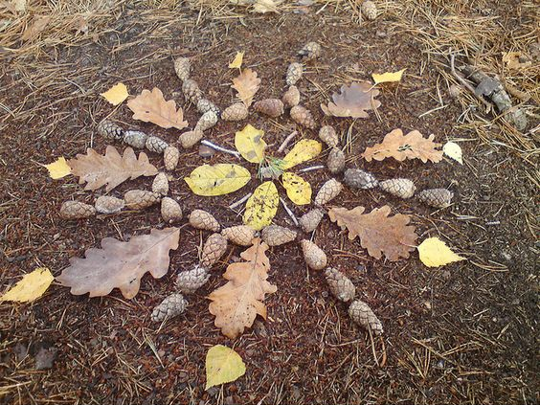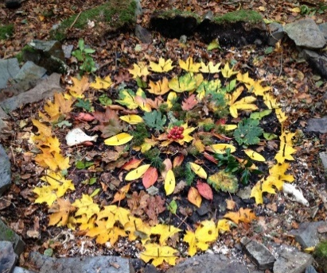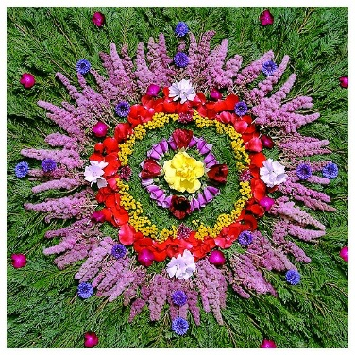

Music
Molly Malone
D G G G G B
G G A A A A C
A B A G D’ B B A G A
D G G G G B
G A A A A C
A B D’ C B D’
C B G A G

 | Activity 1 | Activity 2
Monday | 45 seconds of each activity  15 seconds rest  1. lunges  2. Sit ups  3. Squats  4. Burpees  5. jog on the spot  Repeat this circuit 3 times | Make up a game that involves a wall and two balls.  The game must have five clear rules.
Tuesday | 2 km jog – time yourself | Make a treasure hunt
Wednesday | 45 seconds of each activity  15 seconds rest  1. press ups  2. toe touches  3. Plank  4. Jumping jacks  5. Russian twist  Repeat this circuit 3 times | Play an outdoor game your parent used to play when they were young.
Thursday | 2 km jog – try beat your previous time | You have 10 minutes to collect natural materials from outside which are similar to all the colours of the rainbow.
Friday | 5km brisk walk | Dance to your favourite song
P.E.
Caitheamh Aimsire
Box 1 Week 7

Put into sentences and learn

Gaeilge | Béarla
Bainim taitneamh as ____. | I enjoy ____.
Tá mé go maith ag ____. | I am good at ____.
Is bréa liom ____ ach is fearr liom ____ ná aon rud eile. | I love ____ but I prefer ____ to anything else.
An imríonn tú ar fhoireann? | Do you play on a team?
Imrím / Ní imrím ar fhoireann _____ . | I play / I do not play on a _________ team
Déanaim _______ gach Luan  Déanaim _______ gach Mháirt  Déanaim _______ gach Chéadaoin  Déanaim _______ gach Déardaoin  Déanaim _______ gach Aoine  Déanaim _______ gach Satharn  Déanaim _______ gach Domhnach | I do _____ every Monday  I do _____ every Tuesday  I do _____ every Wednesday  I do _____ every Thursday  I do _____ every Friday  I do _____ every Saturday  I do _____ every Sunday

Gaeilge | Béarla
peil (Ghaelach) | (Gaelic) football
sacar | soccer
rugbaí | rugby
iománaíocht | hurling
camógaíocht | camogie
cispheil | basketball
leadóg | tennis
snámh | swimming
gleacaíocht | gymnastics
lúthchleasaíocht | athletics
rothaíocht | cycling
cearáité | karate
marcaíocht ar chapall | horse riding
cluiche | match
traenáil | training
foireann | team
club áitiúil | local club
captaen | captain
bainisteoir | manager
réiteoir | referee

Abair – To say

Aimsir Chaite (inné) | Aimsir Láithreach (gach lá, gach óiche) | Aimsir Láithreach (amárach, tseachtain seo chugainn)
Dúirt mé | Deirim | Déarfaidh mé
Dúirt tú | Deir tú | Déarfaidh tú
Dúirt sé | Deir sé | Déarfaidh sé
Dúirt sí | Deir sí | Déarfaidh sí
Dúramar (sinn) | Deirimid (sinn) | Déarfaimid (sinn)
Dúirt sibh | Deir sibh | Déarfaidh sibh
Dúirt siad | Deir siad | Déarfaidh siad
Ní dúirt mé | Ní deirim | Ní déarfaidh mé
An ndúirt tú? | An ndeir tú? | An ndéarfaidh tú?

Rewrite the full sentences using the correct verb from the box above. The first one is done for you.
1. (Abair tú) do phaidreacha inné.
Dúirt mé mo phaidreacha inné.________________________________________________________
2. (Abair sinn) ár bpaidreacha ar a sé a chlog gach lá.
__________________________________________________________________________________
3. (Abair sí) go raibh maith agat tar éis lóin inné.
__________________________________________________________________________________
4. An (abair tú) rud éigin amárach?
__________________________________________________________________________________
5. “An (abair siad) aon rud leis an múinteoir inné?” arsa Mamó.
__________________________________________________________________________________
6. (Abair na páistí) go raibh ocras orthu tar éis scoil inné.
__________________________________________________________________________________
7. Mar a (abair an seanfhocal), níl aon tinteán mar do thinteán féin!
__________________________________________________________________________________
8. “(Abair sinn) slán leat an tseachtain seo chugainn,” arsa Seán. __________________________________________________________________________________
9. (Abair an léitheoir nuachta) an nuacht ar a naoi a chlog gach oíche.
__________________________________________________________________________________
10. Ní (abair mé) cúpla focal faoin gcluiche inné. __________________________________________________________________________________

Bí – To be

In aimsir Láithreach we use táim when you are doing something right now – Táim ag obair (I am working).
We use bím when you do something all the time – Bím ag caint ar scoil (I ‘do be’ talking at school’)

Aimsir Chaite (inné) | Aimsir Láithreach (gach lá, inniú, i gconaí (always)) | Aimsir Fháistineach (Amarach, bhliain seo chugainn, níos deanaí (later))
Bhí mé | Táim / Bím | Beidh mé
Bhí tú | Tá tú/Bíonn tú | Beidh tú
Bhí sé | Tá sé/Bíonn sé | Beidh sé
Bhí sí | Tá sí/Bíonn sí | Beidh sí
Bhíomar (sinn) | Táimid/Bímid (sinn) | Beimid (sinn)
Bhí sibh | Tá sibh/Bíonn sibh | Beidh sibh
Bhí siad | Tá siad/ Bíonn siad | Beidh siad
Ní raibh mé | Níl mé/Ní bhím | Ní bheidh mé
An raibh tú? | An bhfuil tú?/An mbíonn tú | An mbeadh tú?
1. (Bí sé) tinn, fanann sé sa leaba inniú.
__________________________________________________________________________________
2. (Bí sinn) préachta leis an bhfuacht ar scoil inné.
__________________________________________________________________________________
3. (Bí siad) ag dúl ar saoire go dtí an Fhrainc an bhliain seo chugainn.
__________________________________________________________________________________
4. “(Bí luch) sa chistin inné,” arsa Lisa.
__________________________________________________________________________________
5. (Bí mé) déanach don bhus ach d’fhan an tiománaí liom inné.
__________________________________________________________________________________
6. (Bí Mamaí) ag caint leis an mbúistéir maidin amárach.
__________________________________________________________________________________
7. (Bí leabhair) go fúirseach sa leabharlann.
__________________________________________________________________________________
8. (Bí) ocras ort i gcónaí!
__________________________________________________________________________________
9. Ní (bí Max) ag tafann ar maidin!
__________________________________________________________________________________
10. (Bí sinn) tuirseach traochta nuair a sroichfimid barr an choic níos deanaí.
__________________________________________________________________________________

