Hi boys.
I hope you had a good week!
I have given lots of feedback on your History and Science / Geography projects. The standard is very high. I especially want to give a shout out to Dan on completion of excellent History project. For anyone who has yet to submit please send them on.
I have enjoyed reading all your stories. I also appreciated the photograph of Jakub’s human sized art. Well done! Send on all completed assignment so I can assess how you are getting on.
I have included work for this week. Obviously Monday is a bank holiday so no work has been assigned for this day.
If you go to Ms. Broderick / Ms. Lawless make sure to access their work on the link on the website.
If there are any problems let me know.
Remember the work you are doing now will stand to you next year.
Regards
S. Fox

Maths
Answers from last week 28
WEEK 28 Monday 1. 4 2. 0.625 3. 1 4. 0 5. 27 6. 60 7. 9.1 8. 0.025 9. ---10. 12.6 11. 180 12. ÷ 13. 6 14. 30m2 15. 11 16. 240 17. 21:15 18. €447.50
Tuesday 1. hexagonal pyramid 2. 0 3. 2 4. 8 5. 75 6. 3.02 7. 12 8. ---9. 31.2 10. 18cm2 11. 30km 12. 5 13. 1 in 2 14. 0.035 15. x 16. 39 17. €54.60 18. 109.20
Wednesday 1. obtuse 2. 360˚ 3. 2 4. 1 in 2 5. 8 6. 10 7. 6∕10 8. 3∕8 9. 0 10. €17.50 11. 11 12. 9 13. €4.50 14. 69 15. 1, 3, 9, 27 16. 2.5l 17. 12.54m 18. 560
Thursday 1. 9 2. 5.8 3. 121 4. 720 5. 6.5, 6 4∕10, 5.6, 5¼ 6. 29.3 7. €0.55 8. cylinder 9. 3m2 10. 0 11. 60 12. 122,337 13. 1∕8 14. 3 15. 8 16. 12 tonnes 17. 288 18. €2,016
TEST week 28 1. €20 2. 1 3. 5 4. 9 5. 2 6. (b) 7. 39 8. 8 9. 10 10. €15 11. 24cm 12. 391.7 13. 19:36 14. 10 15. 5 16. 9:11 17. 85 18. 9∕20 19. 70 20. --- Problems 21. 18:00 22. €300 23. 45 24. €9 25. 750g
Give yourselves a mark at the bottom of the page and let me know how you got on. If you are unsure how to get the correct answer send me an email and I will explain. Make sure to do your Maths work in pencil and correct it in red pen.
You have no Master your maths this week
Mathemagic - Please let me know how you found working from this book last week. We will focus on the measurement of Time this week. I don’t expect you to do every question on the page. Ensure you read what I have asked to be completed. Some of the question can be tricky so make sure to read the info boxes to help.
This book can be accessed on CJ Fallon website online. Log in as a student (you may need an email address that you can use). Select level, class, subject, series, title and online book. The name of the book should appear and click on it. It should then download.
Time p 91 - 94
Tue | p 91  Q1(e + f)  Q2 (a-e)  Q3 – Q7 (c + d)
Wed | p92 Q1,2,4,6,8,10
Thur | P 93 Q1,3,5 (f), 6 (e), 7(b), 11,12,13
Fri | P94 Q 1-8

Irish
- Fuaimeanna agus focail (Aonad 18)
- Continue to revise some of the Irish phrases of the week. (see attached at end of worksheets). They will stand to you next year. See how many you can answer without looking at the sheet.
- Scríbhneoireacht (Writing):
Conas a beidh an aimsir? (What will be weather be like?)
Leigh Réamhaisnéis na haimsire (Read the Weather forecast)
Scríobh Réamhaisnéis na haimsire do gach lá i do chóipleabhar (Write the weather forecast for each day of the week in your copy) It can be fictional!
Réamhaisnéis na haimsire
(Weather forecast)

Dé Luain (Mon)  Dé Máirt (Tue)  Dé Céadaoin (Wed)  Déardaoin (Thurs)  Dé hAoine (Fri)  Dé Sathairn (Sat)  Dé Domhnach (Sun | - ar maidin (in the morning)  - sa tráthnóna (in the afternoon)  - san óiche (at night) | - beidh an aimsir ag dul i bhfeabhas (weather will be improving)  - beidh an aimsir ag dul in olcas (weather will be getting worse)  - beidh sé an-ghaofar (it will be very windy)  - beidh sé scamallach (it will be cloudy)  - beidh sé fuar agus scamallach. (it will be cold and cloudy)  - beidh sé ag stealladh báistí (it will be poring rain)  - beidh sé tirim (it will be dry)  - beidh tintreach agus toirneach (there will be thunder and lightening)  - beidh sé ag plúchadh sneachta (it will be snowing heavily)  - beidh brat sneachta ar an talamh (there will be covering of snow on the ground)

Mar shampla (Example)
Dé Luain
Beidh sé an-ghaofar ar maidin. Beidh sé scamallach sa tráthnóna. Beidh sé scamallach san óiche.

Dé Máirt
Beidh an aimsir ag dul in olcas. Ar maidin, beidh sé fuar agus scamallach. Ansin, sa tráthnóna beidh tintreach agus toirneach ann. San óiche beidh sé ag plúchadh sneachta.

Dé Céadaoin
Beidh an aimsir ag dul i bhfeabhas ar maidin. Beidh sé scamallach ach tirim sa tráthnóna. Beidh sé tirim san óiche.

English
Spellbound – No spellbound this week
Starlight – No Starlight this week

Tue – Research some poetry and choose one poem which you really like and you want to explore further.
Wed – Record your chosen Poem and Poet. Write an analysis of your poem under Theme – what is the surface theme of the poem? What is the underlying theme?
Thurs – List five techniques that are evident in this poem and write a paragraph on each. These may include imagery, rhyme, rhythm, alliteration, onomatopoeia etc.
Fri – Write a poem based on the same theme as the poem you have chosen.

History –

Using the below heading create a PowerPoint on World War two
- Time and chronology (use date and a timeline of events)
- Change and continuity (show similarities and differences between pre and post war)
- Cause and effect (appreciate that World War 1 had a number of causes and outcomes)
- Using evidence (examine and use critically a wide range of historical evidence photographs, pictures, objects, memories of older people, buildings, stories and songs, written sources, films, other media, information and communication technologies)
- Synthesis and communication (Organise the information and structure your presentation well, communicate using graphs, maps, photographs, art, etc.)
- Empathy (imagine and discuss the feelings and motives of people in the past, discuss how an event in the past may have been perceived by those who participated in it)

Science
Continue with challenge - to design and make a land yacht.

Initial problem: Can you design and make a vehicle that is powered by the wind? (a hair dryer)

Craft-handling skills : This task provides opportunities for the development of the skills of cutting, joining, making triangular joins, making holes and strengthening structures.

Step 1: Exploring, planning and making
1. Think about boats
• the shape of the base
• the materials used for the base
• the materials used for the sails.

2. Think of the parts essential for the boat to work.

3. Consider how the sailing boat could be adapted for use on land.
Some suggestions may include
• adding an axle and wheels

4. Choose suitable materials.

5. Sketch designs of the land yacht.
Think about
• the shape of the base (chassis, wheels and axle)
• the materials used for the base (a cardboard box, wood, straws)
• the materials used to help it move
Wheels
axle upon which to place the wheels
how to join the axle to the base (chassis)

6. Consider the materials that will be used for the mast.
Where should you attach the mast to the boat. How will you do this
e.g. tape, thread, staples, tape or glue.

Step 2: Making and evaluating
1. Make the vehicle and adjust sketches as necessary
2. Test the vehicle.
3. Make necessary changes
4. Design a test to evaluate your land yacht.
5. Record your results.
6. Consider how to improve the design by using different shapes and materials.

Religion
May is the month when Catholics traditionally focus on Mary, the Mother of Jesus. The practice dates back at least 700 years and is still observed around the world today. May is seen as the beginning of new life and the start of summer, which makes this a logical time for the celebrations of Mary, who brought life into the world.
This week I would like you to create a May Altar - A special place for Mary in your home or bedroom. As the month progresses add to your May Altar. It may include a picture of Mary, a candle, a prayer written out for Mary, some flowers, a rosary beads, a drawing for Mary, a list of people that you would like Mary to be extra kind to, picture of what you are thankful for, a statue of Mary etc. Take a picture of your May altar and send it onto me.
Each day set aside a few minutes to pray to Mary. Thank her for the things you are grateful for, ask her to help protect those you love and say the ‘Hail Mary’. Look up other prayers we can say to Mary. Research some icons of Mary from around the world.

Art
I have only received a few picture of your Art so will give you another week to complete / create another. Don’t forget to give a title to your finished work of Art

Create a structure using outdoor materials (rocks, grass, sticks, wood, clay, sand, leaves).
Be aware of its shape, height, balance, texture, pattern, space, colour etc.
Give it a title.
Take a picture and send it onto me.

Music
Learn ‘The Fields of Athenry’ on the tinwhistle. The D in bold is high D (D’)

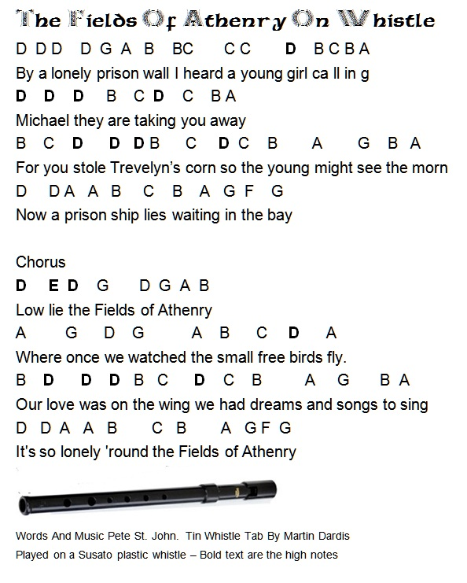

P.E.
Please send on completed challenge chart for Active School Challenge.
Also I would love to see some pictures that show you completing the activities. These may be included in our application for our flag.
Active Home Week Timetable
 | Activity 1 | Activity 2
Tuesday | PDST Beyond the Classroom Catching Part 1  https://vimeo.com/412274551 | Joe Wicks workout
Wednesday | PDST Beyond the Classroom  Catching Part 2  https://vimeo.com/412280738 | Create your own obstacle course.
Thursday | PDST Beyond the Classroom  Catching Part 3  https://vimeo.com/412282658 | Active housework (15 minutes)
Friday | Combine your favourite activities from the above videos | 2km walk/run with your family

An aimsir

Write these into a copy and complete using helping words where necessary.
Gaeilge | Béarla
Is dócha go mbeidh ____. | It will probably be ____.
Conas a bhíonn an  aimsir (i rith an ____)? | How is the weather  (during ____)?
Bíonn an aimsir ____  (i rith an ____). | The weather is ____  (during ____).
Cén séasúr is fearr leatsa? | Which season do you prefer?
Is fearr liom an ____. | I prefer the ____.
Is é ____ an séasúr is  fearr liom. | ____ is the season that I prefer.
An rud is mó a thaitníonn liom faoi ná ____. | The thing that I like best about it is ____.

Gaeilge | Béarla
Cén sórt aimsire atá  ann inniu? | What is the weather like today?
Tá an aimsir ____ inniu. / Tá sé ____. | The weather is ____ today. / It is ____.
Cén sórt lae atá ann? | What sort of day is it?
Lá ____ atá ann. | It is a ____ day.
Tá sé ag dul i bhfeabhas / ag dul in olcas. | It is getting better / worse.
Tá sé ____ fós. | It is still ____.
Beidh / Ní bheidh ____ amárach. | It will be / will not be ____ tomorrow.
Tá súil agam go mbeidh sé ____ amárach. | I hope it will be ____ tomorrow.

L Helping words
Gaeilge | Béarla | Gaeilge | Béarla
bog | mild | álainn / deas | lovely / nice
te | hot | drochlá | bad day
fuar | cold | ag taitneamh | shining
grianmhar | sunny | ag spalpadh anuas | beating down
scamallach | cloudy | ag cur báistí | raining
fliuch | wet | ag séideadh | blowing
tirim | dry | ag cur sneachta | snowing
gaofar | windy | ag plúchadh sneachta | snowing heavily (blizzard)
ceomhar | foggy | stoirm | storm
grian | sun | fiáin | wild
scamall | cloud | toirneach | thunder
báisteach / fearthainn | rain | tintreach | lightning
gaoth | wind | tornádó | tornado
ceo | fog | hairicín | hurricane
sioc | frost | crith talún | earthquake
sneachta | snow | súnámaí | tsunami
leac oighir | ice | dóiteán foraoise | forest fire
bogha báistí | rainbow | tonn teasa | heatwave

